**PROJECT TOPICS-**

**1. Market Basket Analysis-** Using Apriori/Association Rules on dataset Online Retail for analyzing the frequent purchase of items and which items was purchased more.

**2. Consumer Behavior Analysis-** Using K-Means Clustering (Unsupervised Learning) on dataset Mall Customer for analyzing the behavior of customers.

**3. HR Analytics-** Using Random Forest Classifier and Decision Tree Classifier on dataset employee turnover for analyzing an organization’s people problems.

1. **Market Basket Analysis-**

Have you ever asked yourself how the store managers decide on product shelf placement in retail stores? There must be some strategy behind it, right? It can’t be just a random choice. Almost on daily basis, you receive product purchase recommendations from variety of sources where you have left your “digital fingerprint”. In many cases these recommendations make sense, what leaves you puzzled, how did they figured it out?

The Market Basket Analysis is perhaps the most famous method in Association Mining techniques arsenal. It’s all about finding frequent pairs, triples, quadruples of products from historical transactions or market baskets.

Here I have Used dataset of ONLINE RETAIL and perform Market Basket Analysis.

About the Dataset-

It is a transactional data set which contains all the transactions occurring between 01/12/2010 and 09/12/2011 for a UK-based and registered non-store online retail. The company mainly sells unique all-occasion gifts; many customers of the company are wholesalers.

My ultimate goal is to do Market Basket Analysis on this data and figure out the association rules.

Library Used-

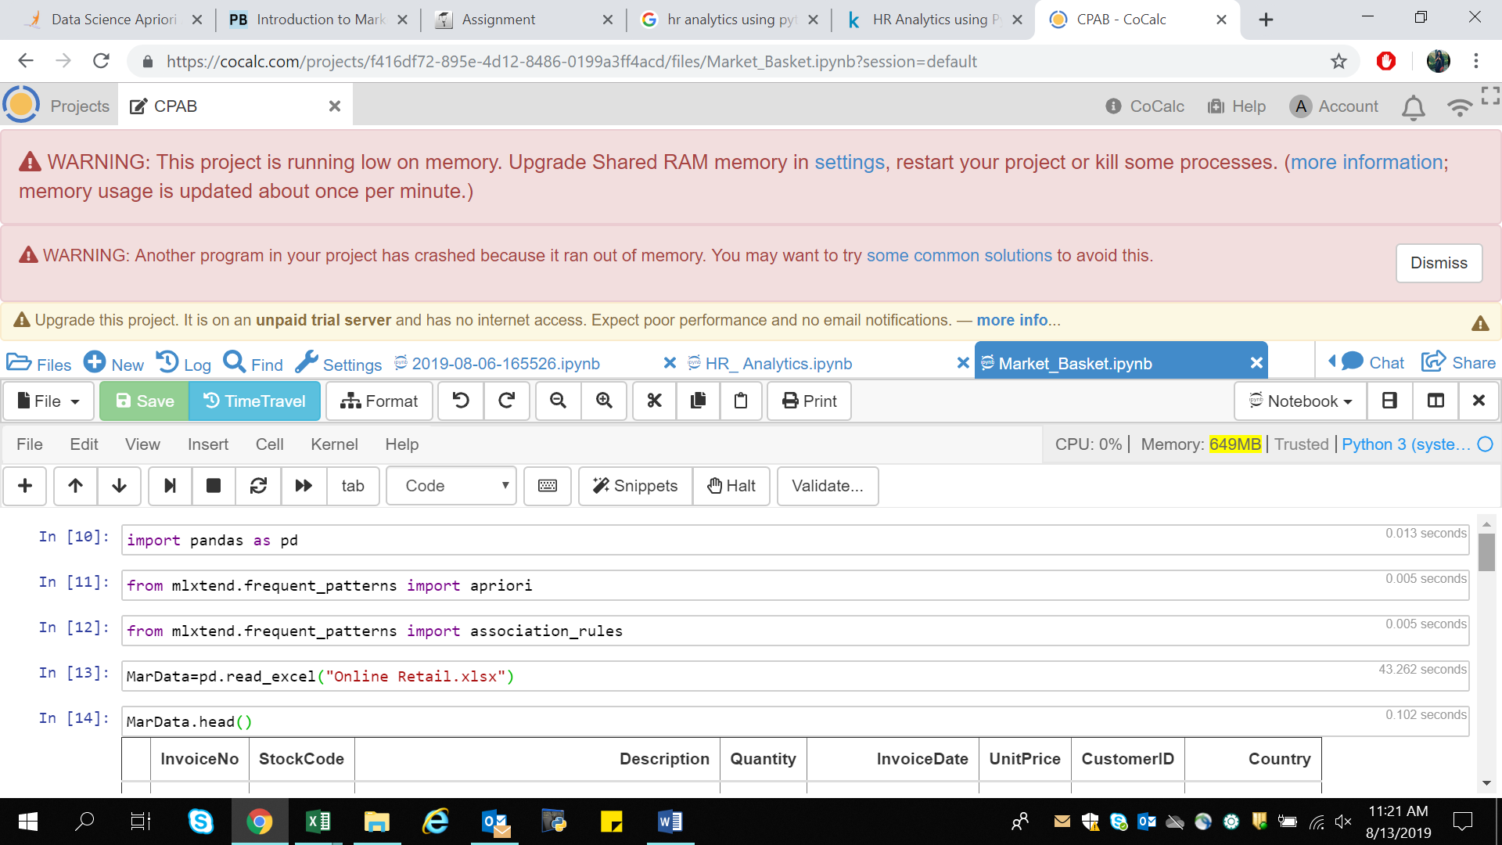

1. Pandas- for data manipulation and data analysis.
2. Apriori- for market basket analysis.
3. Association_rules- for market basket analysis

Data is imported using pandas library under name MarData.



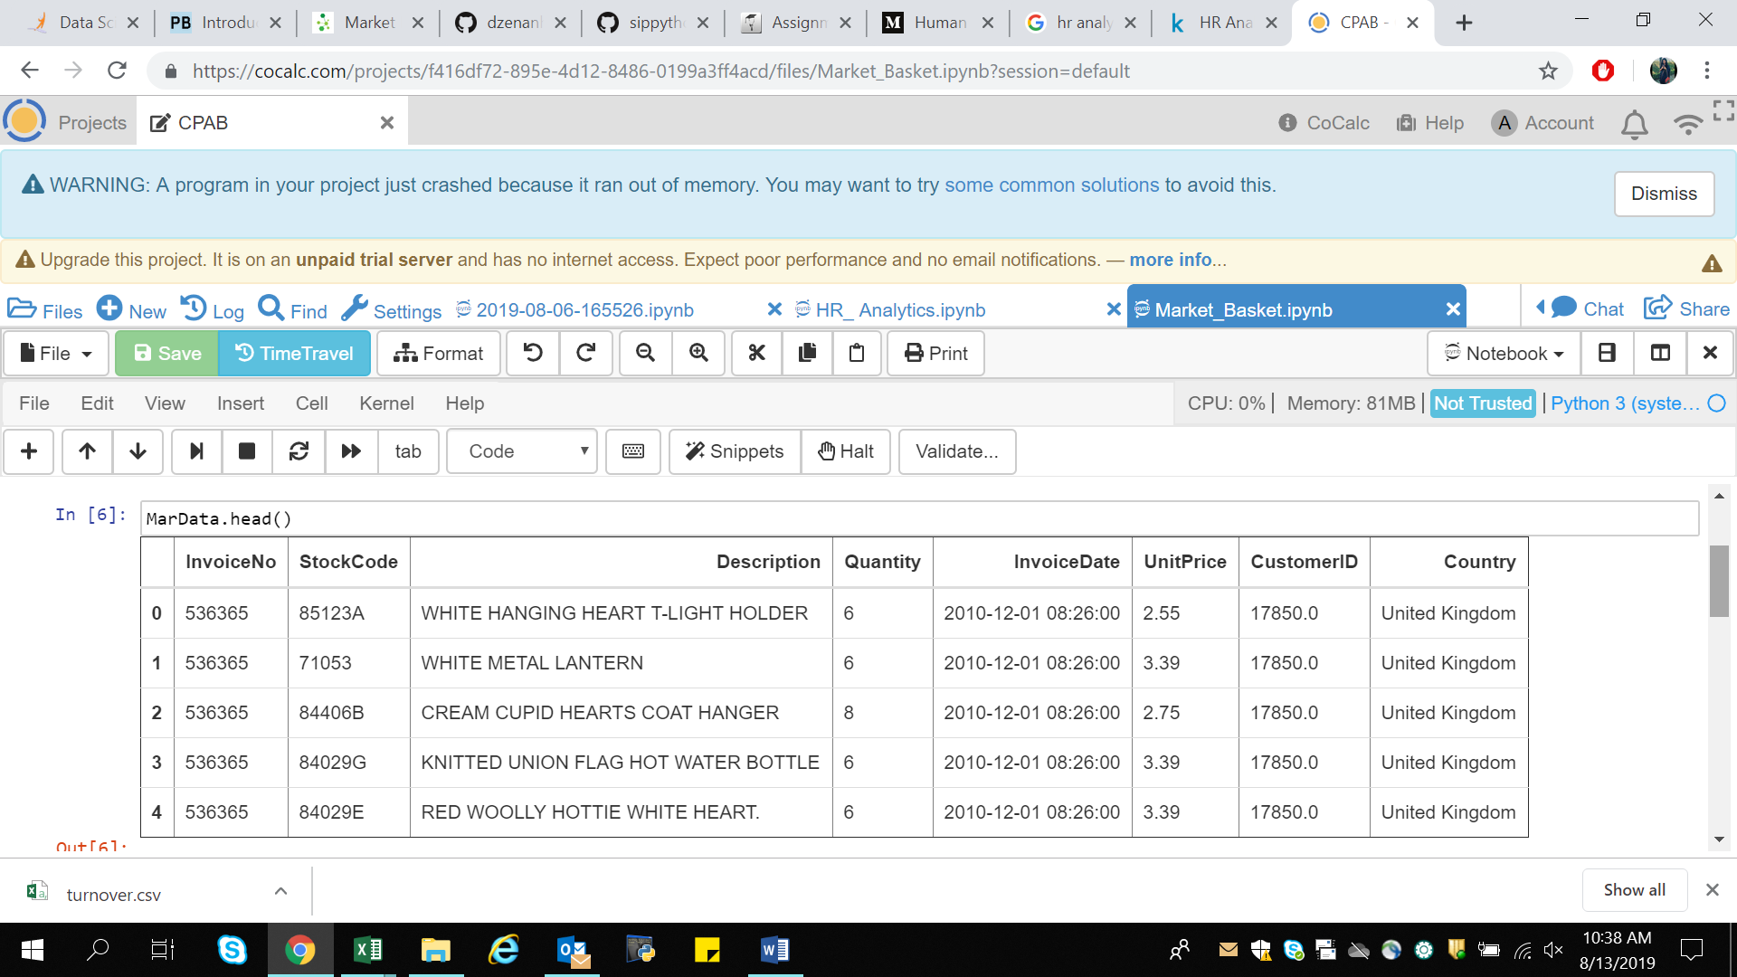

The above picture shows the data contained by the dataset.

Data Cleaning-

To check data contain any white spaces or Null values can be viewed using dataobject.info() functions.

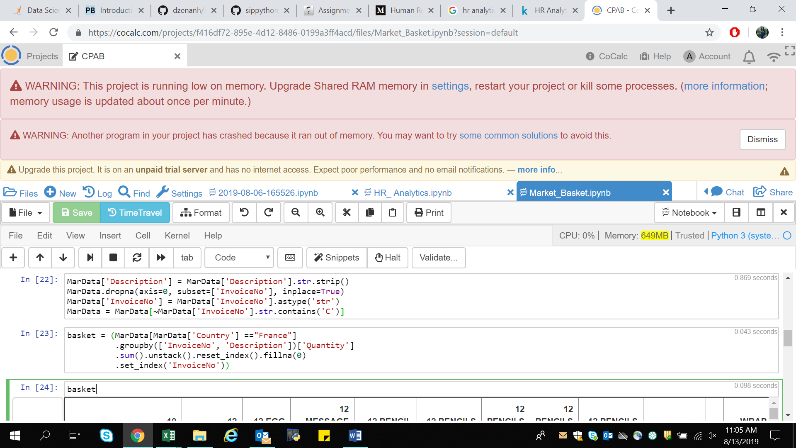

1. str.strip - to remove Leading and trailing spaces.
2. dropna - to remove null values.
3. astype - to cast entire pandas object to the same type.
4. ~MarData[‘InvoiceNo’].str.contains(‘C’) – to remove credit transaction from InvoiceNo

After data cleaning the dataset looks like in the following format.

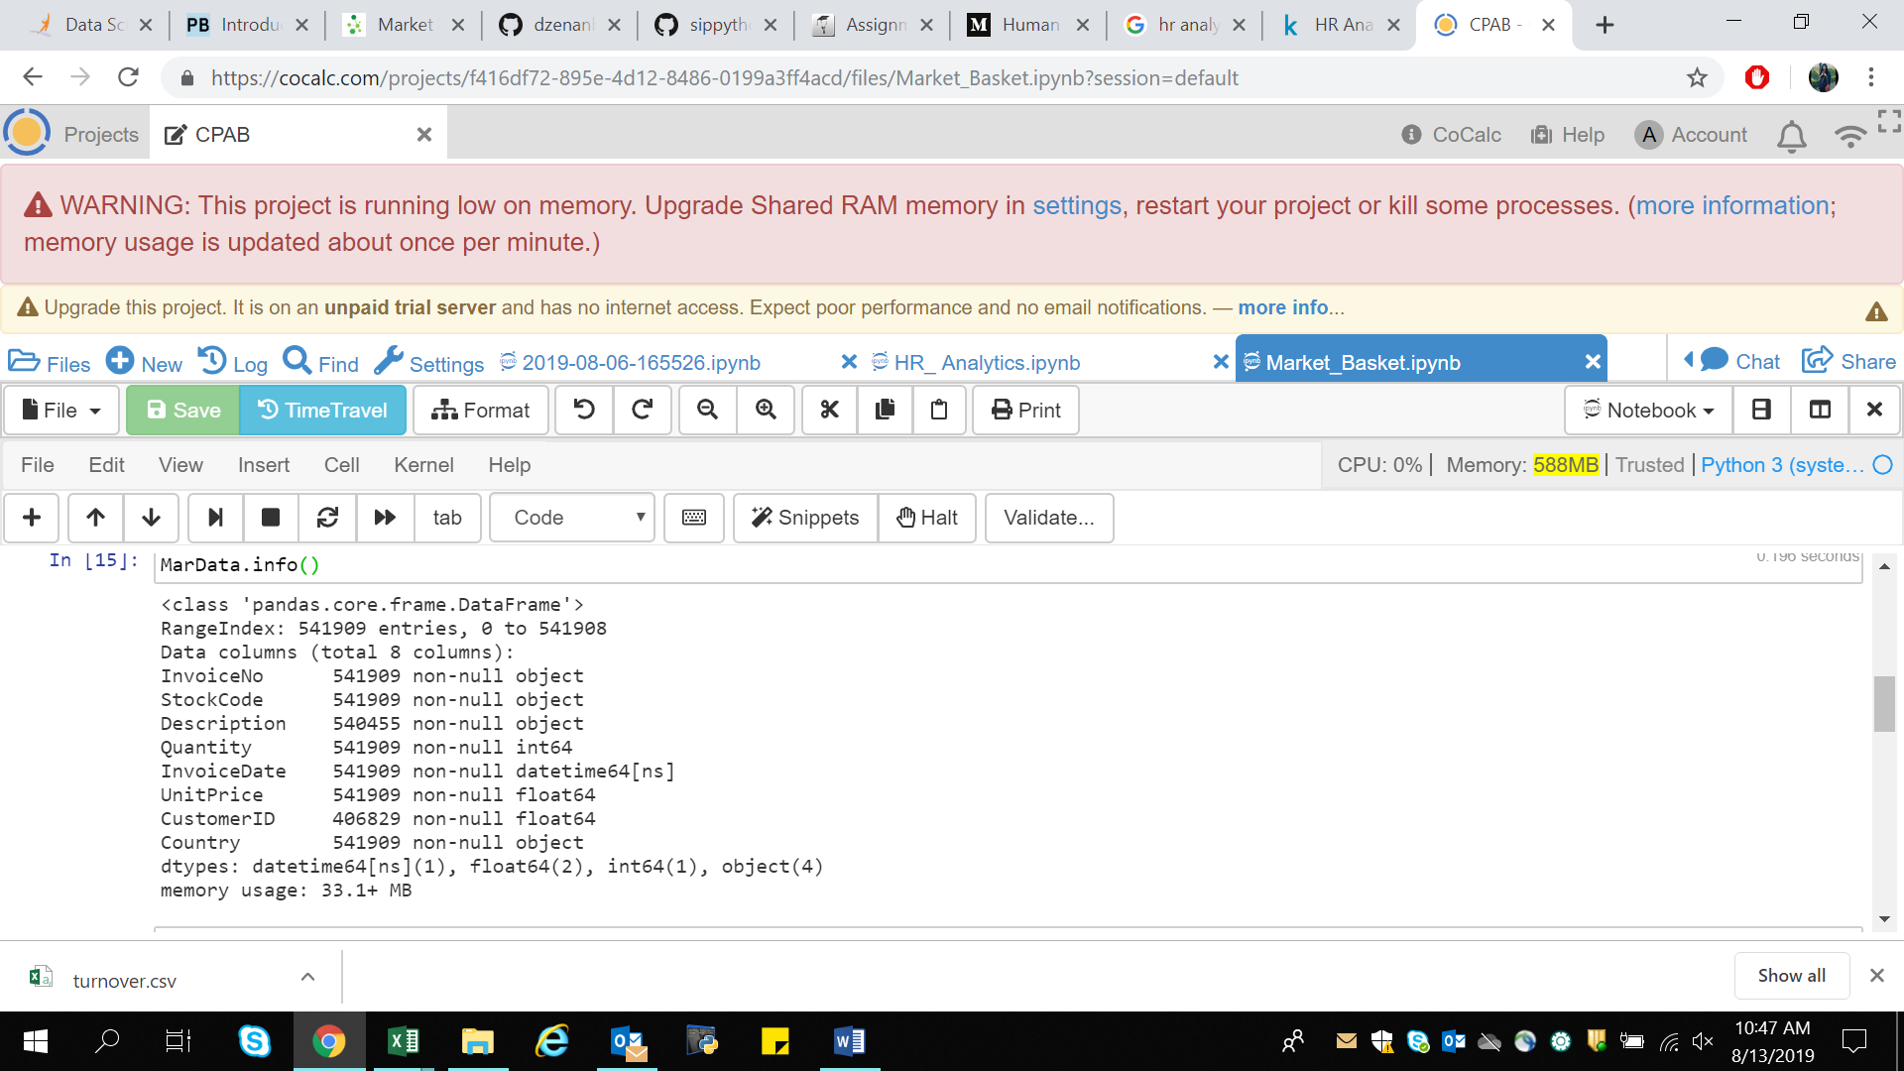

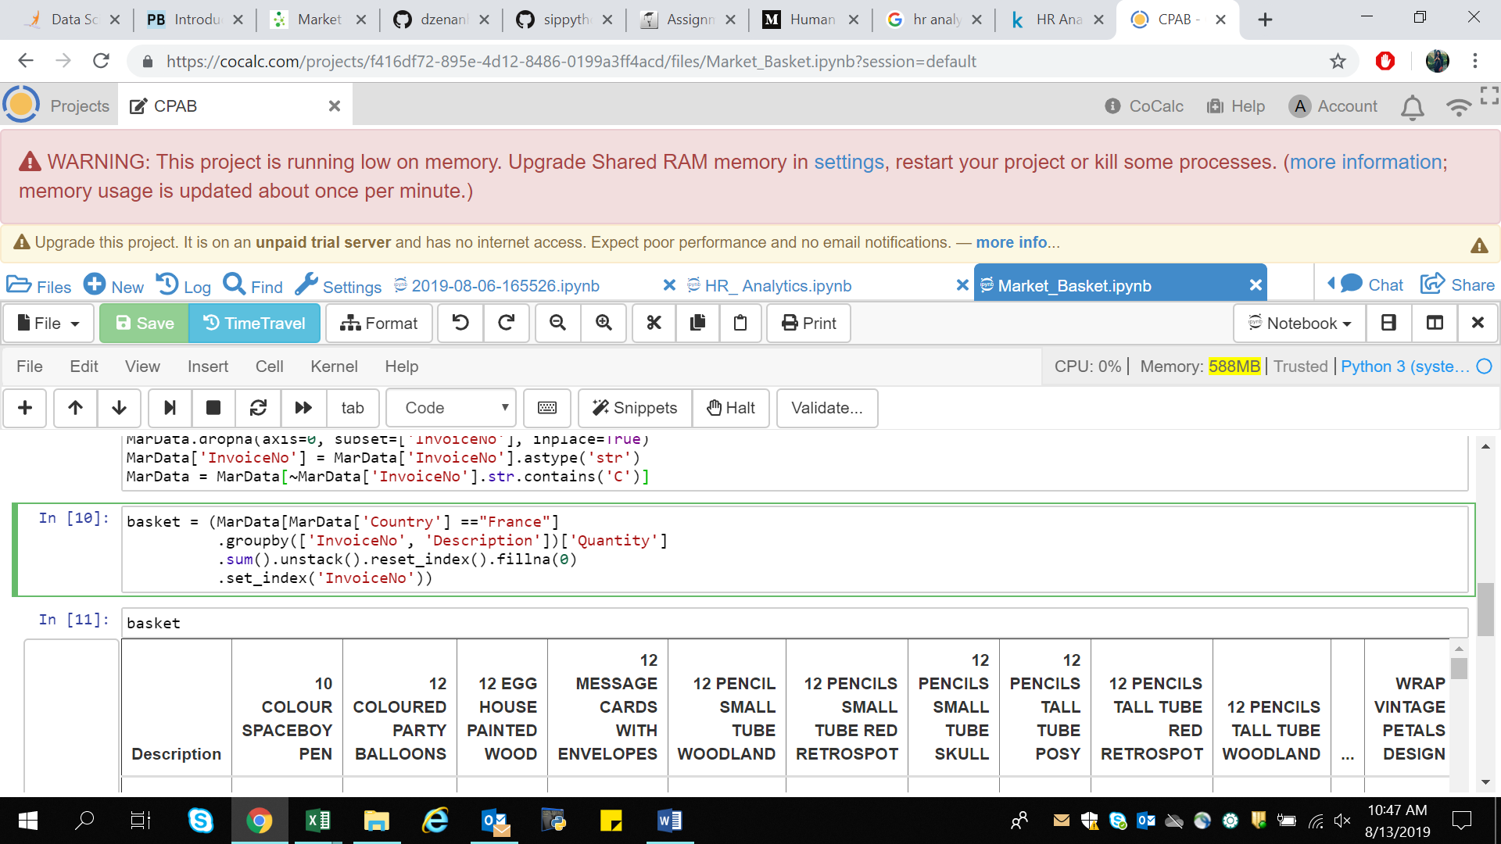After Data cleaning to consolidate the items into 1 transaction per row with each product. Here, I will be performing analysis for the sales in France (similarly can do for other Country just replacing the name of the country with other say United Kingdom).

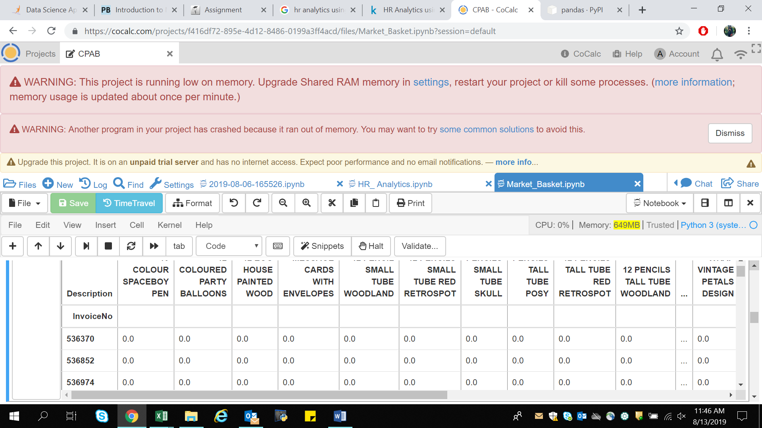

There are a lot of zero’s in the above data but we also need to make sure any positive values are converted to a 1 and anything less than 0 is set to 0. This step will complete the one encoding of the data and remove the postage column (since that charge is not one we wish to explore).



Now that the data is structured properly, we can generate frequent item sets that have a support of at least 7%.

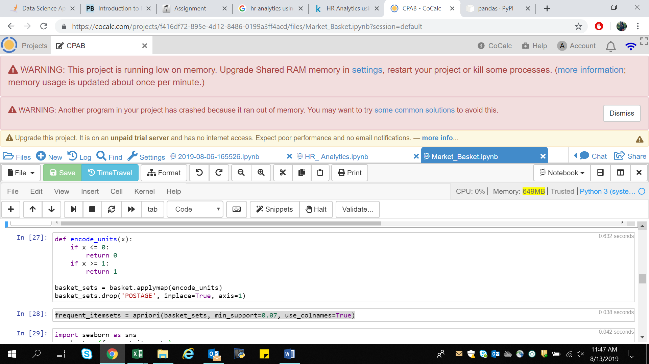

The final step is to generate the rules with their corresponding support, confidence and lift:

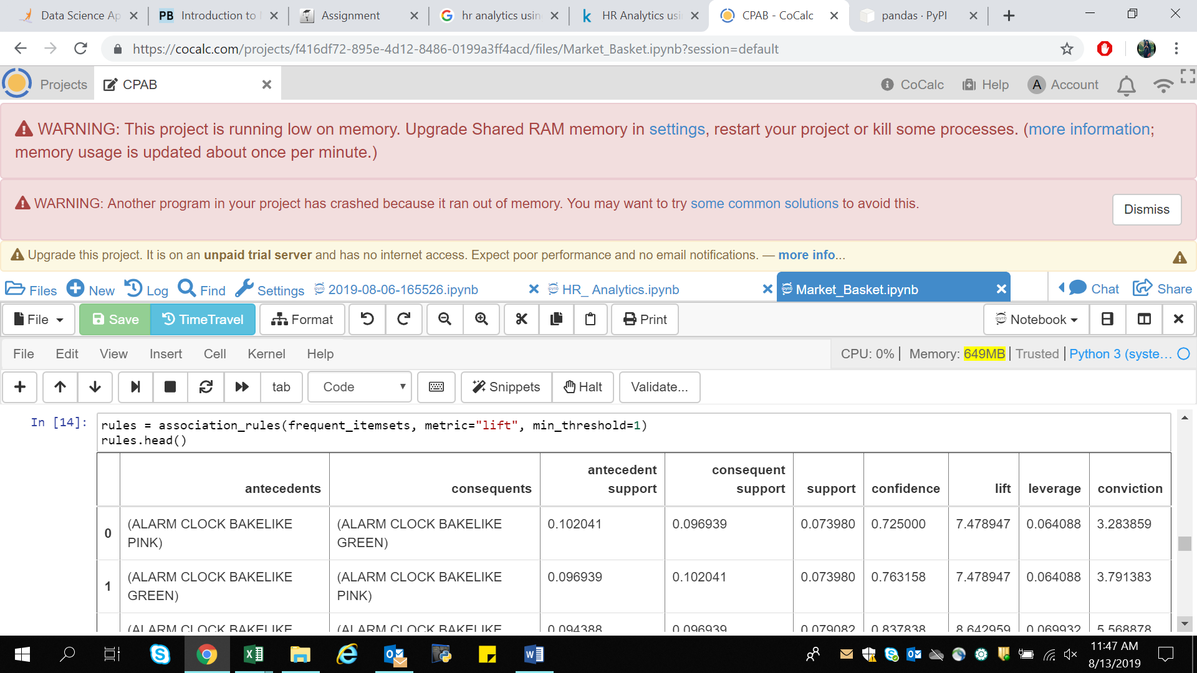

That’s all there is to it! Build the frequent items using apriori then build the rules with association rules.

We can filter the dataframe using standard pandas code. In this case, look for a large lift (6) and high confidence (0.8):

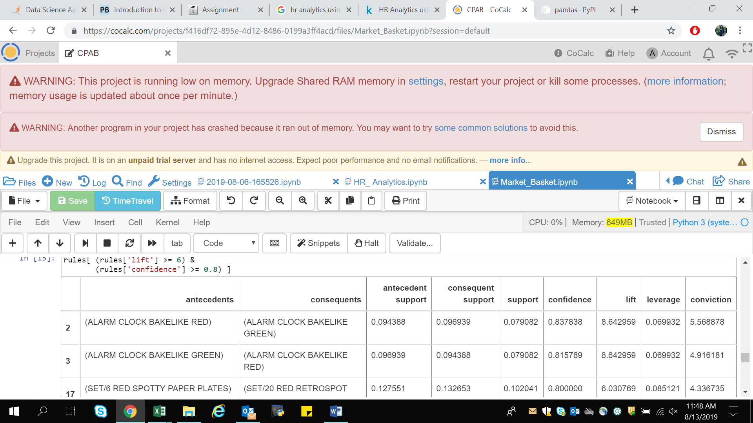

What do the rules say about?

We will find quite a few rules with a high lift value which means that it occurs more frequently than would be expected given the number of transaction and product combinations. We can also see several where the confidence is high as well. This part of the analysis is where the domain knowledge will come in handy.

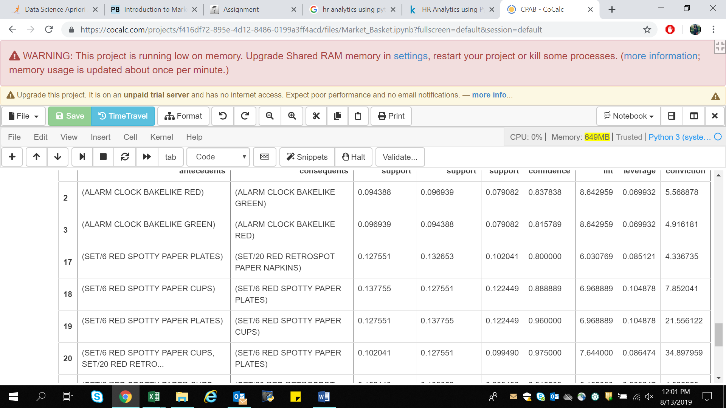

So Here, it seems that the green and red alarm clocks are purchased together and the red paper cups, napkins and plates are purchased together in a manner that is higher than the overall probability would suggest.

At this point, we may want to look at how much opportunity there is to use the popularity of one product to drive sales of another.

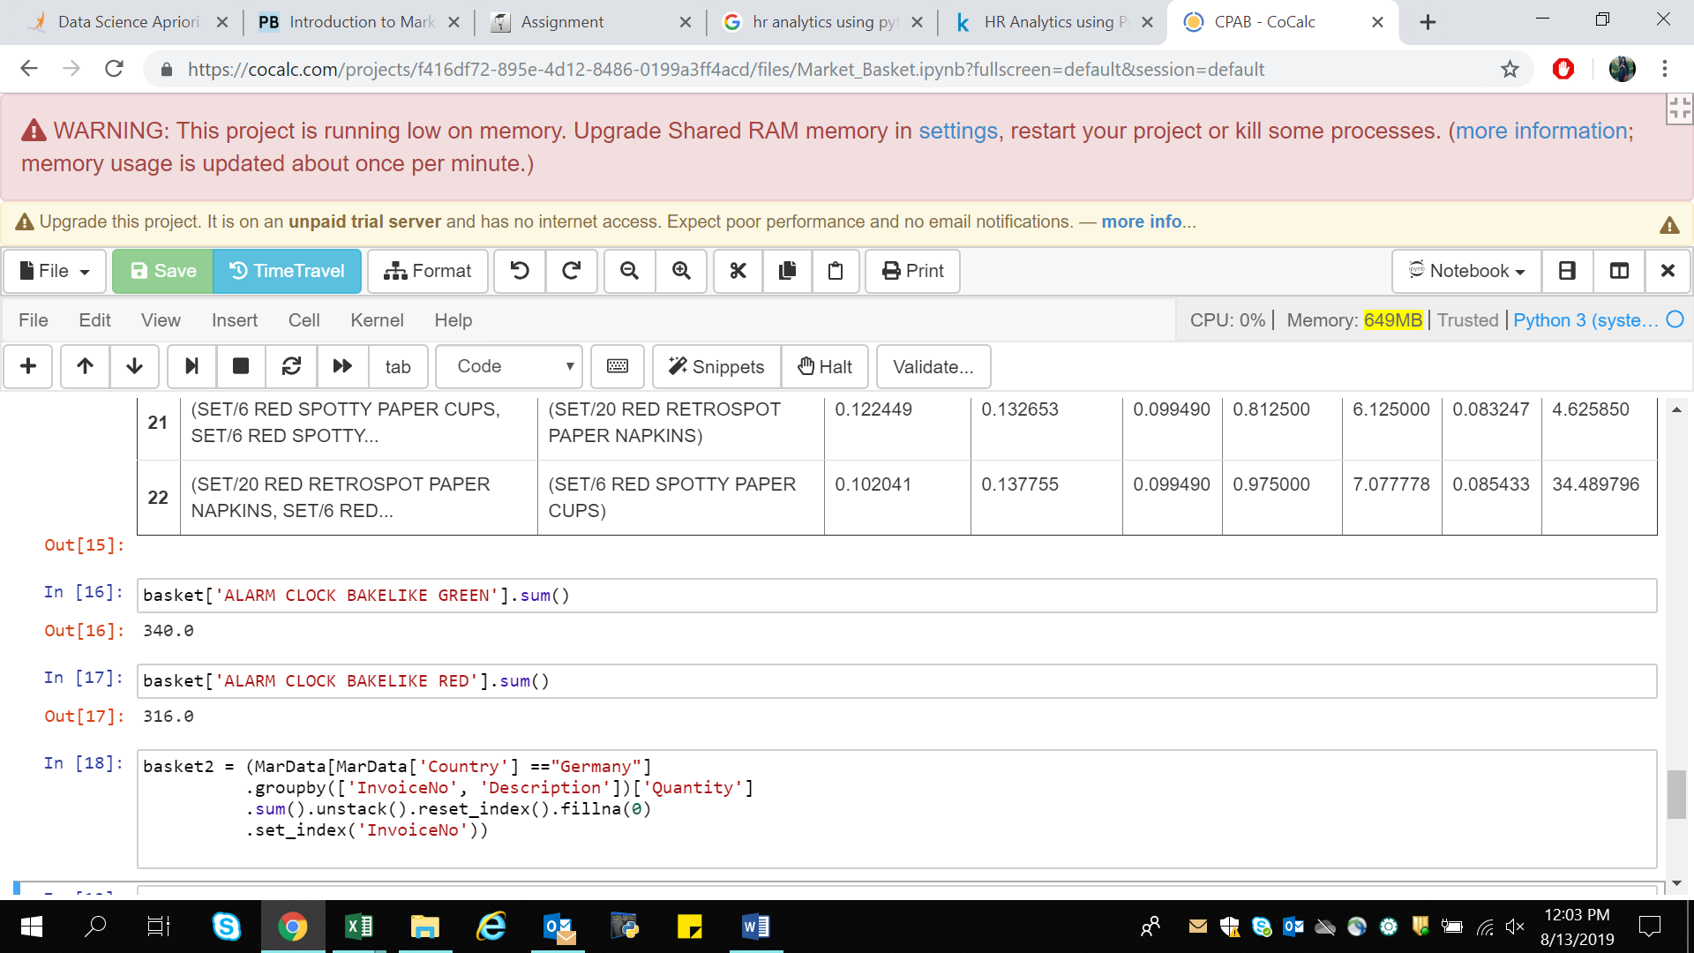

For instance, we can see that we sell 340 Green Alarm clocks but only 316 Red Alarm Clocks so maybe we can drive more Red Alarm Clock sales through recommendations?

1. **Consumer Behavior Analysis-**

It is crucial to understand customer behavior and categorize customers based on their demography and buying behavior. This is a critical aspect of customer segmentation that allows marketers to better tailor their marketing efforts to various audience subsets in terms of promotional, marketing and product development strategies.

So with the help of unsupervised learning (k-means clustering) will be performing consumer behavior analysis.

The objective of any clustering algorithm is to ensure that the distance between data points in a cluster is very low compared to the distance between 2 clusters. In other words, members of a group are very similar, and members of different groups are extremely dissimilar.

Here I have used K-Means clustering with elbow method on Mall Customer dataset.

About the Dataset-

The dataset consists of Annual income (in $000) of 303 customers and their total spend (in $000) on an e-commerce site for a period of one year.

Library Used-

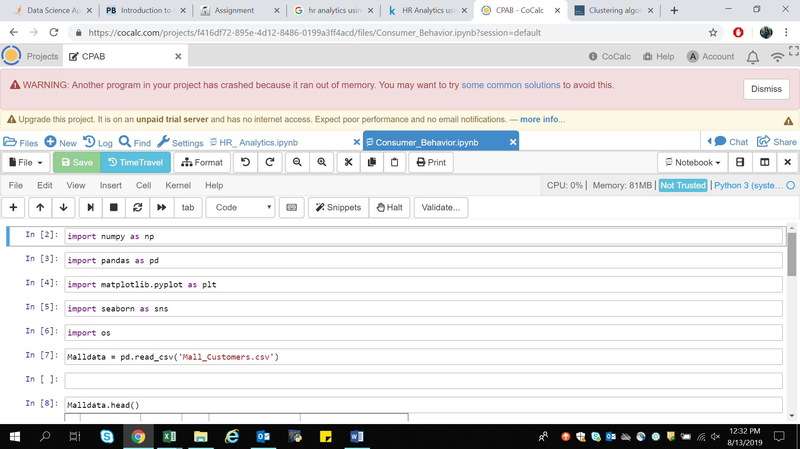

1. pandas- for data manipulation and data analysis.
2. numpy- for high-performance multidimensional array object, and tools for working with these arrays
3. matplotlib.pyplot- for visualization.
4. seaborn- for visualization.
5. os- for directory.
6. kmeans- for clustering.

Data is imported using pandas library under the name Malldata



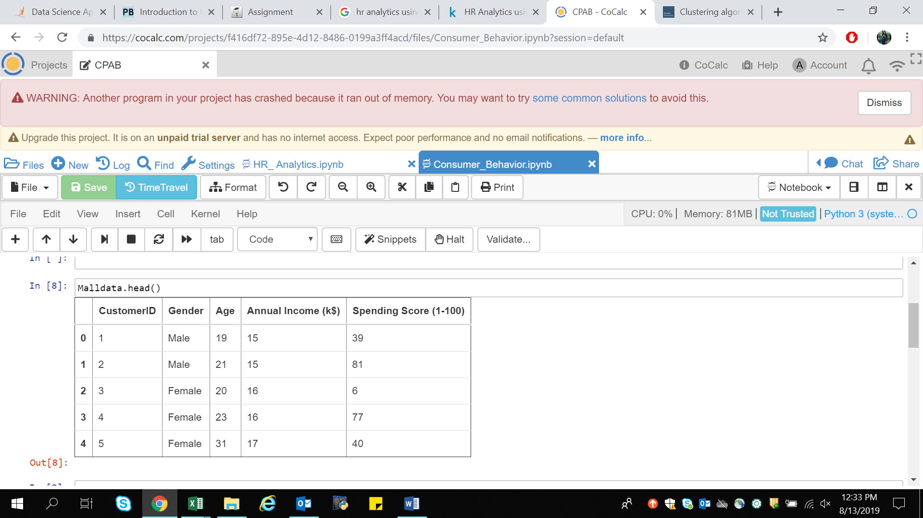

The above picture shows the data contained by the dataset.

Dataset contains 200 rows and 5 columns.

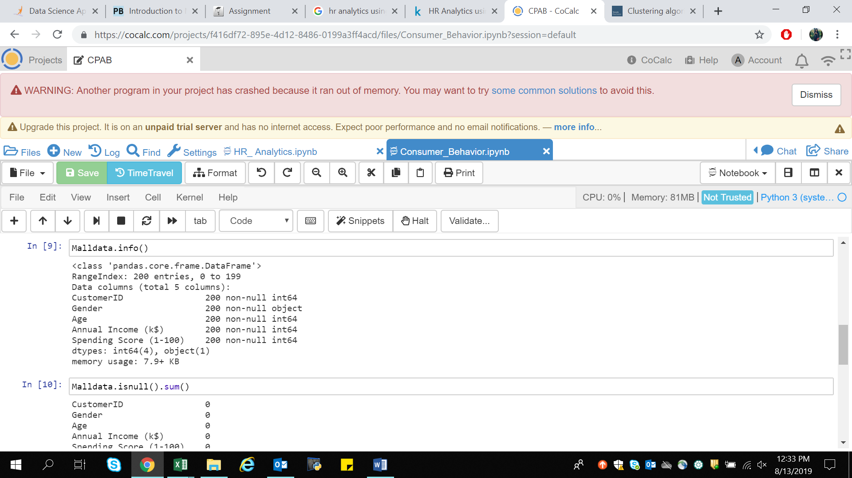

To check data contain any white spaces or Null values can be viewed using dataobject.info() or dataobject.isnull() functions .

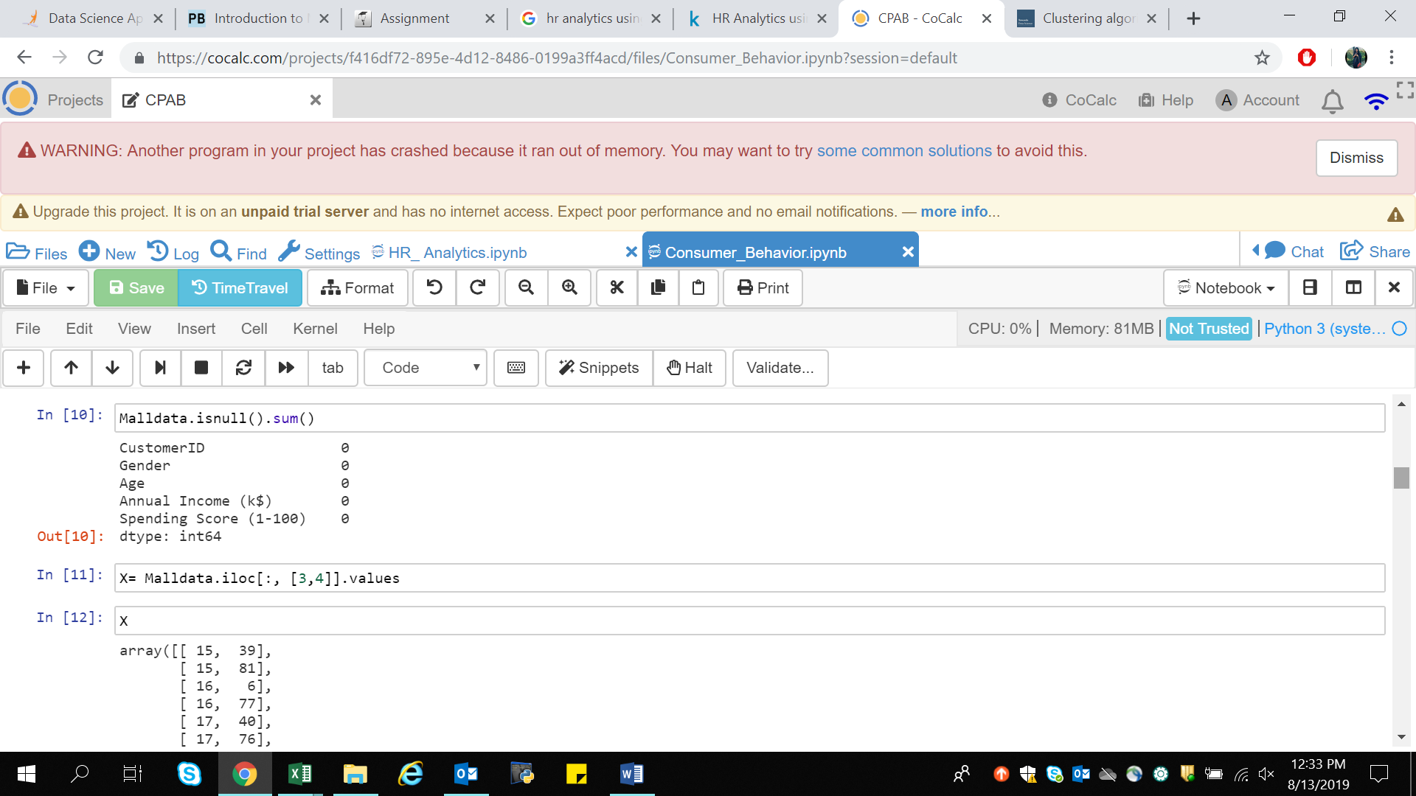

This shows the data contains no Null values. Therefore data cleaning is not required.

For building the model and moving to our next stage of analysis we need to select feature for the model. Here we are considering only 2 features (Annual income and Spending Score) with no Label available.

For the same store the data into some variable using dataobject.iloc[ ].values command



Now for Building the Mode I will be using K-Means Algorithm to decide the optimum cluster number , K-Means++ using Elbow method.

Elbow Method- To figure out K for K-Means++, I will use ELBOW Method.

[K-means](https://en.wikipedia.org/wiki/K-means_clustering) is a simple [unsupervised machine learning](https://en.wikipedia.org/wiki/Unsupervised_learning) algorithm that groups a dataset into a user-specified number (k) of clusters. The algorithm is somewhat naive--it clusters the data into k clusters, even if k is not the right number of clusters to use. Therefore, when using k-means clustering, users need some way to determine whether they are using the right number of clusters.

One method to validate the number of clusters is the elbow method. The idea of the elbow method is to run k-means clustering on the dataset for a range of values of k (say, k from 1 to 10 in the examples above), and for each value of k calculate the sum of squared errors (SSE).

Then, plot a line chart of the SSE for each value of k. If the line chart looks like an arm, then the "elbow" on the arm is the value of k that is the best.

WCSS is within-cluster-sum-of-squares to measures sum of distances of observations from their cluster centroids.

Implementing k-means to get maximum number of clusters. inertia_ is the formula used to segregate the data points into clusters

Plotting the elbow method for visualization of optimal values of k form by using plot() functions.

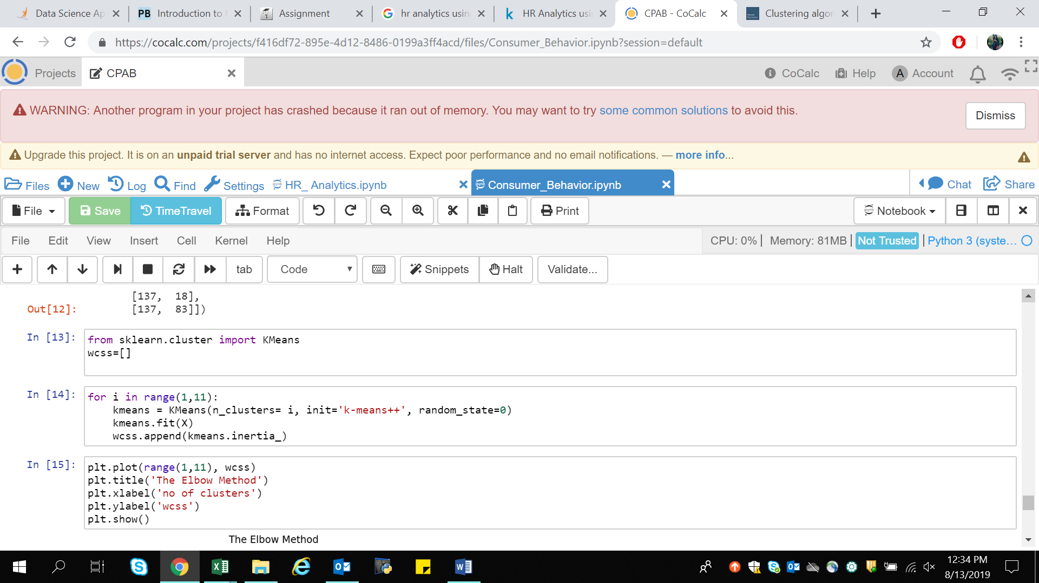

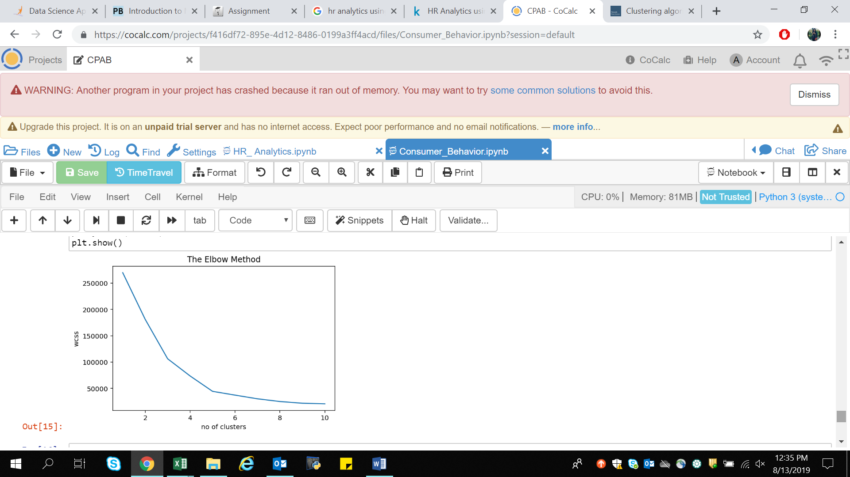

If we see in the above plot last elbow comes at k=5 but if we chose higher range it is little difficult to visualize the ELBOW that is why we are preferring between range (1,11)

With that I got the value of k, k=5.

For unsupervised learning we use "fit_predict()" wherein for supervised learning we use "fit_tranform()".

As we are working with unsupervised learning will be using fit.predict().

y_kmeans is the final model . Now how and where we will deploy this model in production is depends on what tool we are using. This use case is very common and it is used in BFS industry(credit card) and retail for customer segmentation.

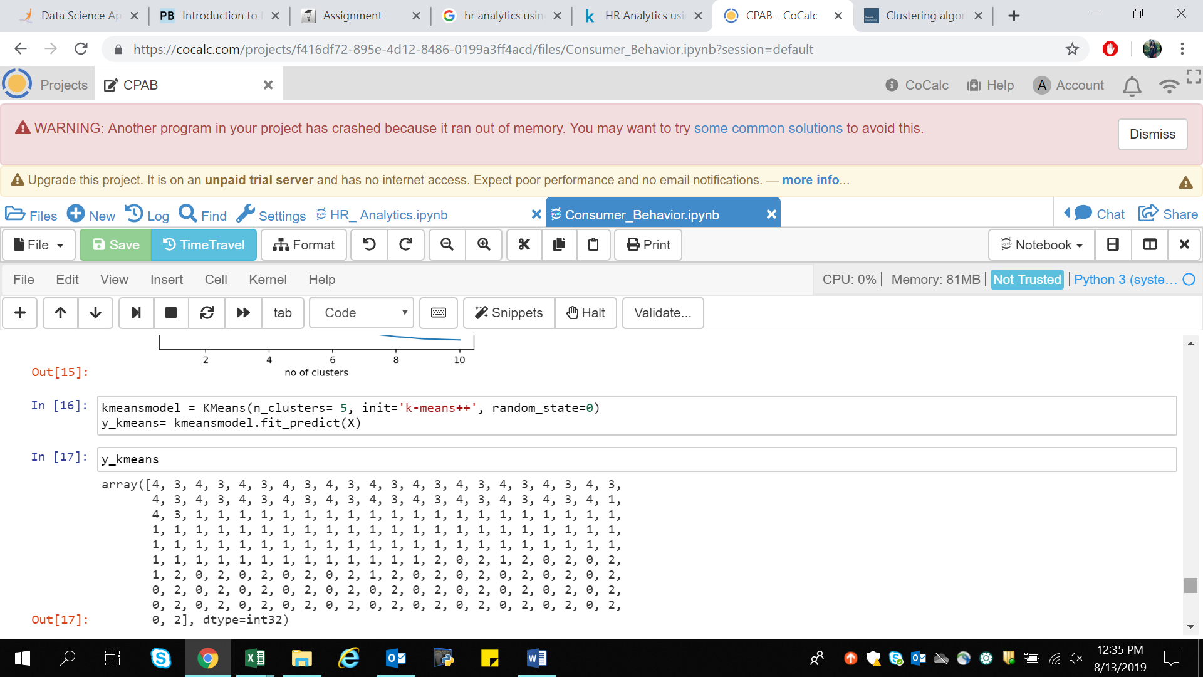For visualizing all the 5 clusters.

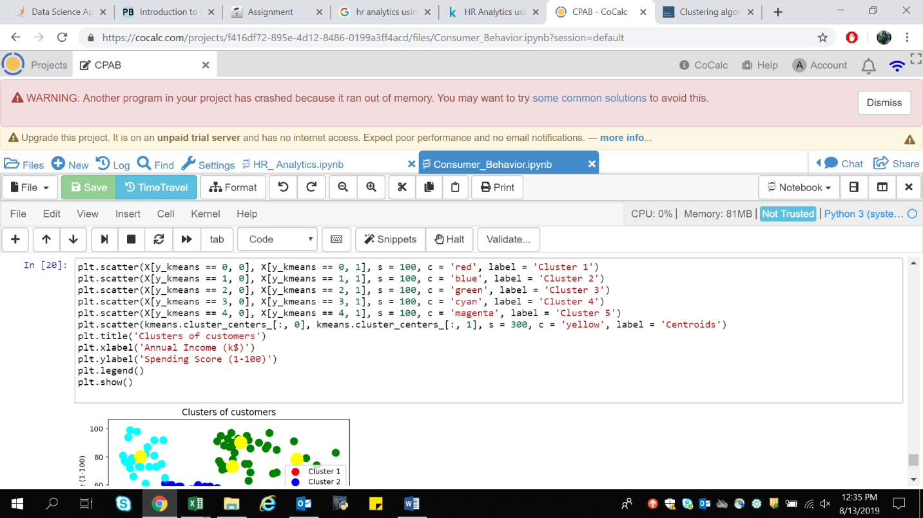

The Below graph represent the model interpretation.

1. Cluster 1 (Red Color) - Earning high but spending less
2. Cluster 2 (Blue Color) - Average in terms of earning and spending
3. cluster 3 (Green Color) - Earning high and also spending high [TARGET SET]
4. Cluster 4 (cyan Color) - Earning less but spending more
5. Cluster 5 (magenta Color) - Earning less , spending less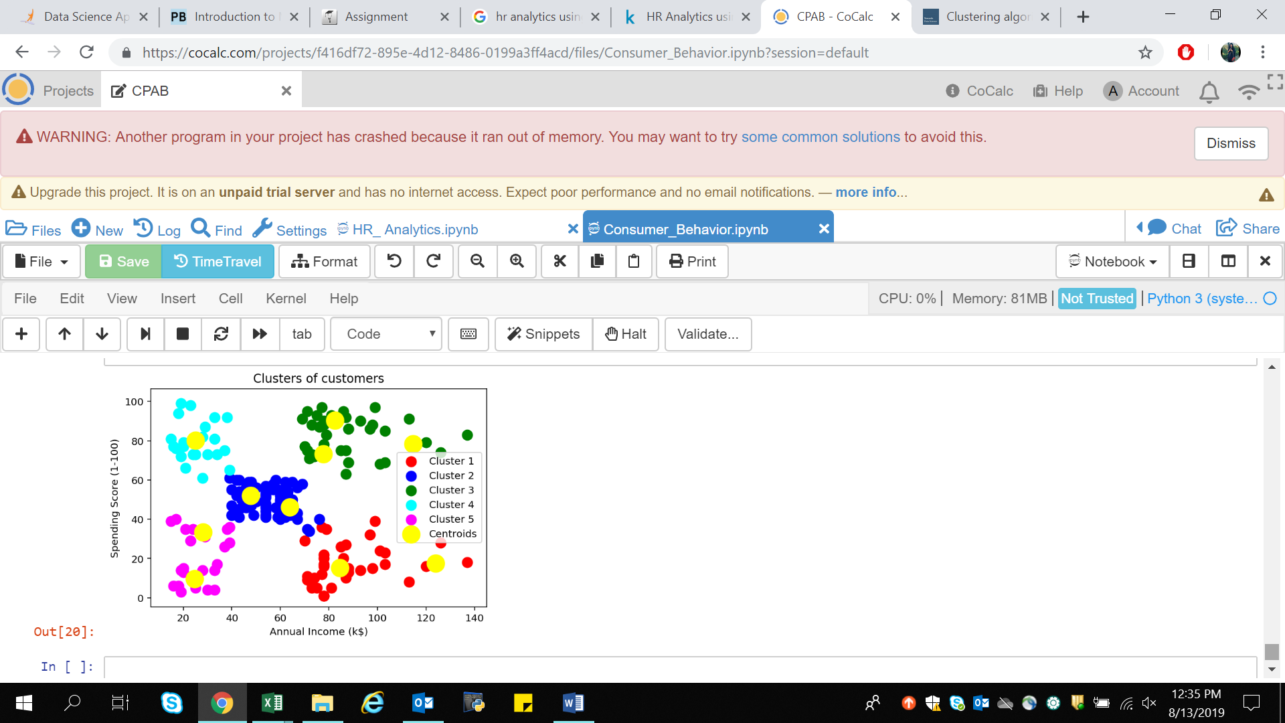.

So what we can analyze from the below clustering is we can put Cluster 3 into some alerting system as they are the target audience and will be helping in increasing the sales of business/retail/malls wherein others we can set like once in a week or once in a month.

As customer is king every customer is valued but with this we got the prior customer to be targeted.

* A typical strategy would focus certain promotional efforts for the high value customers of Cluster 6 & Cluster 3.
* Cluster 4 is a unique customer segment, where in spite of their relatively lower annual income, these customers tend to spend more on the site, indicating their loyalty. There could be some discounted pricing based promotional campaigns for this group so as to retain them.
* For Cluster 2 where both the income and annual spend are low, further analysis could be needed to find the reasons for the lower spend and price-sensitive strategies could be introduced to increase the spend from this segment.
* Customers in clusters 1 and 5 are not spending enough on the site in spite of a good annual income — further analysis of these segments could lead to insights on the satisfaction / dissatisfaction of these customers or lesser visibility of the e-commerce site to these customers. Strategies could be evolved accordingly.

1. **HR ANALYTICS –**

Human Resource analytics is about analyzing an organization’s people problems using data. It enables you to answer critical questions about your organization. For example:

* How high is your annual employee turnover?
* How much of your employee turnover consists of regretted loss?
* Do you know which employees will be the most likely to leave your company within a year?
* Chances of having accident in an organization.

These questions can only be answered using data.

Here I have Used Random forest Classifier and Decision Tree classifier Machine Learning Algorithm on turnover dataset.

About the Dataset-

The turnover dataset contains 14999 rows and 10 columns. The “left” column is where we know if an employee has left. All other columns excluding “sales” are directly or indirectly related to the choice made by the employees. From “sales” we know which department an employee belongs to.

Library Used-

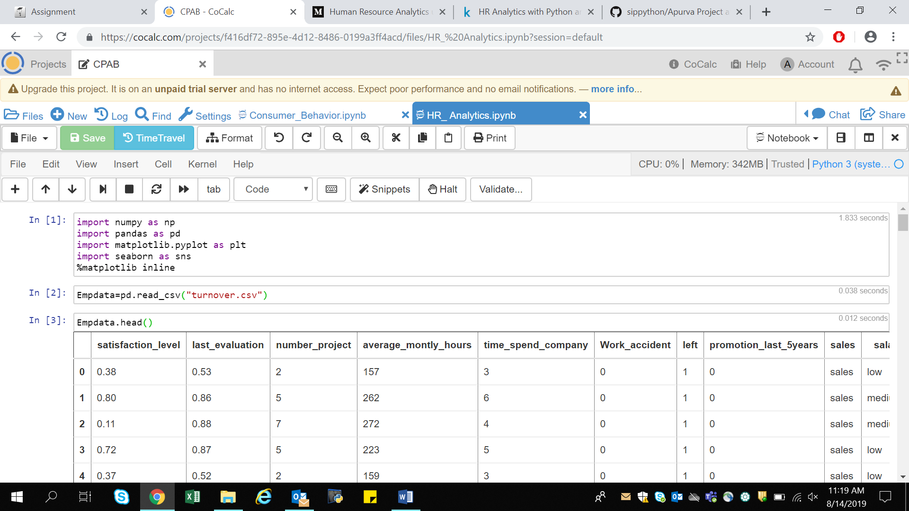

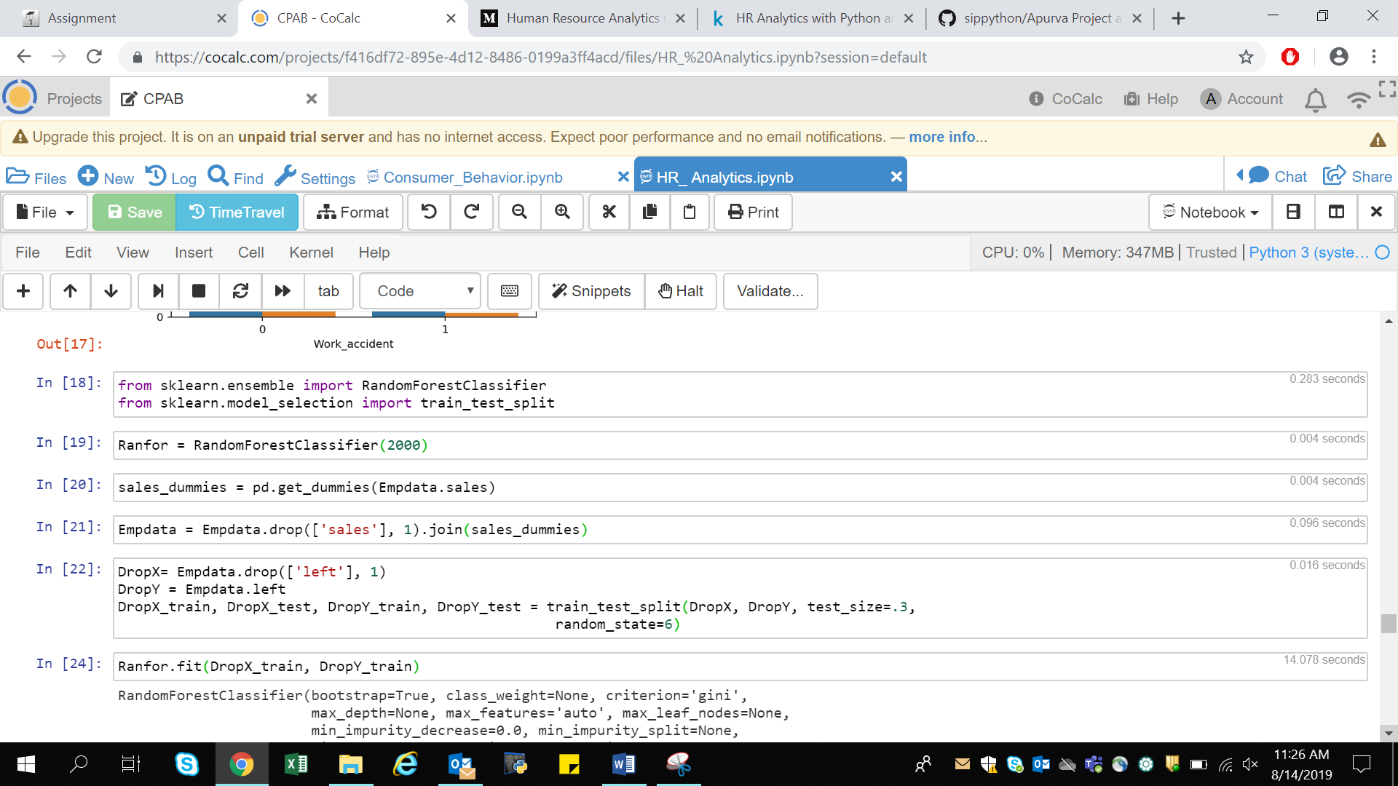

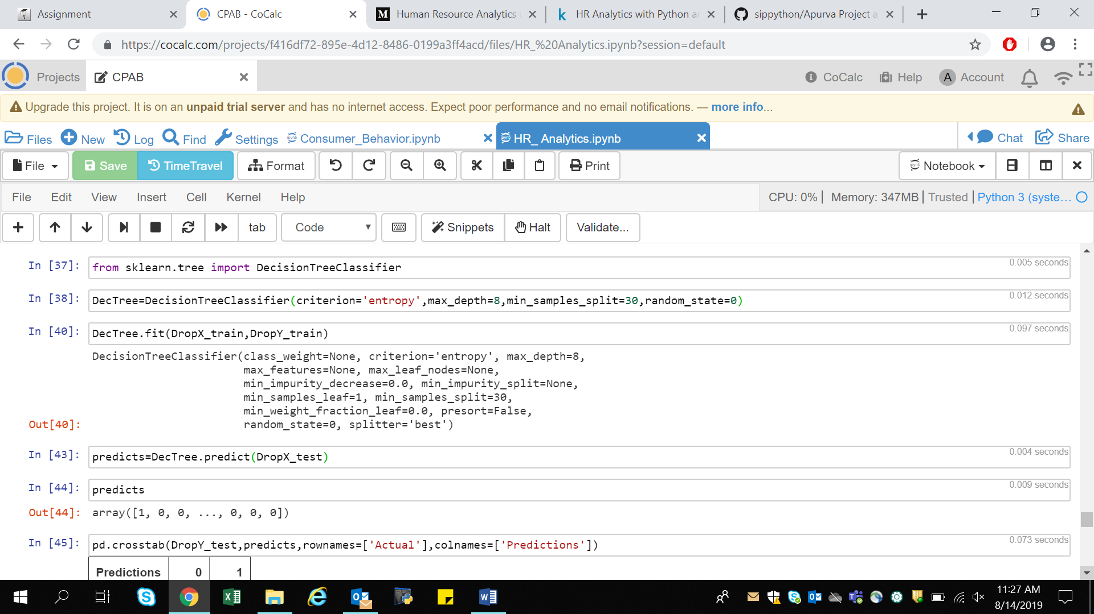

1. Numpy - for high-performance multidimensional array object, and tools for working with these arrays.
2. Pandas - for data manipulation and data analysis
3. Matplotlib.pyplot - for visualization
4. Seaborn - for visualization
5. Sklearn.ensemble.RandomForestClassifier - using sklearn.ensemble for implementing Random Forest Model
6. Sklearn.tree.DecisionTreeClassifier - using sklearn.tree for implementing Decision Tree Model
7. Sklearn.model_selection.train_test_split – for splitting arrays or matrices into random train and test subsets.

Data is imported using pandas library under the name Empdata (dataobject).



The above picture shows the first five rows of the dataset using dataobject.head() (Empdata.head()) function.

Empdata.info() or Empdata.isnull() can be used to check whether the dataset contain any Na or Null values.

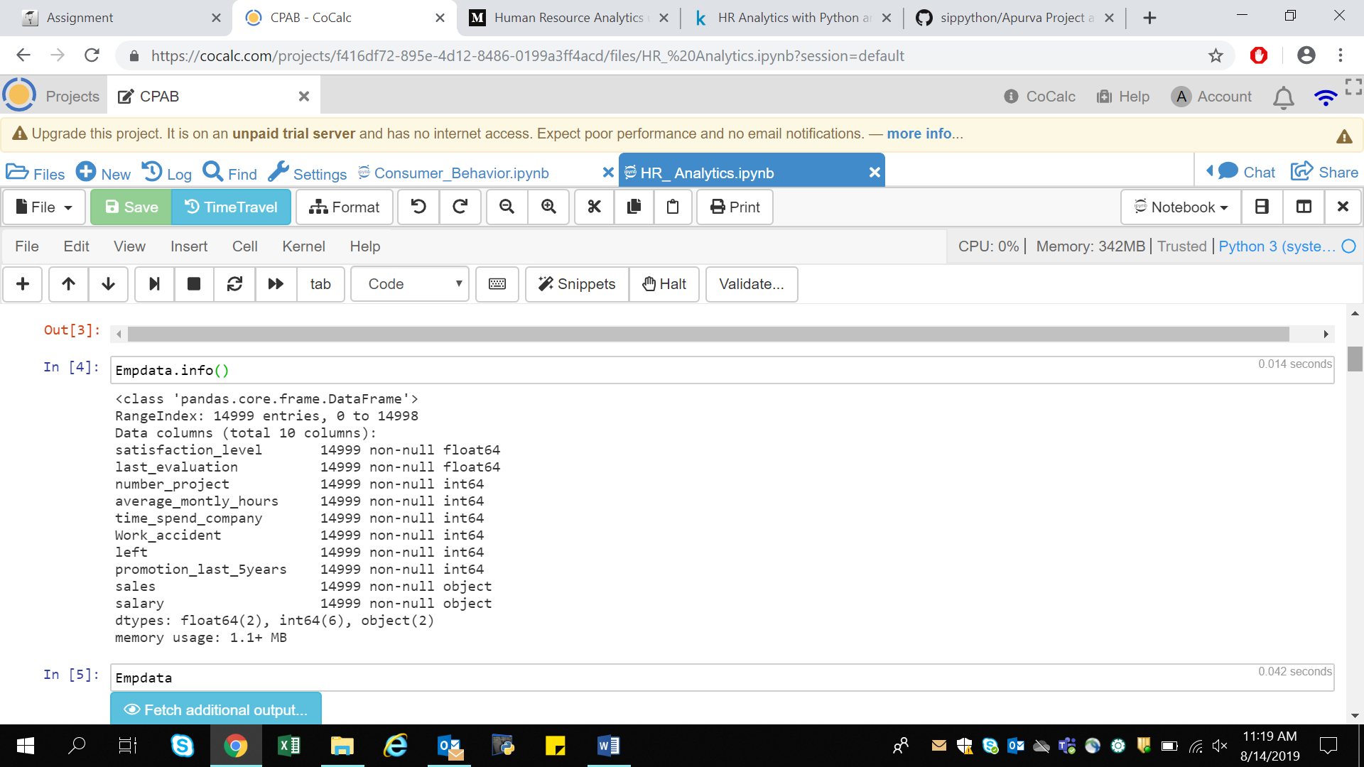

The data does not contain any Null values therefore data cleaning is not required.

Before Building the model, will visualize some features of the dataset.

Will working on the data of the left employee:-

1. Left Employee Ratio

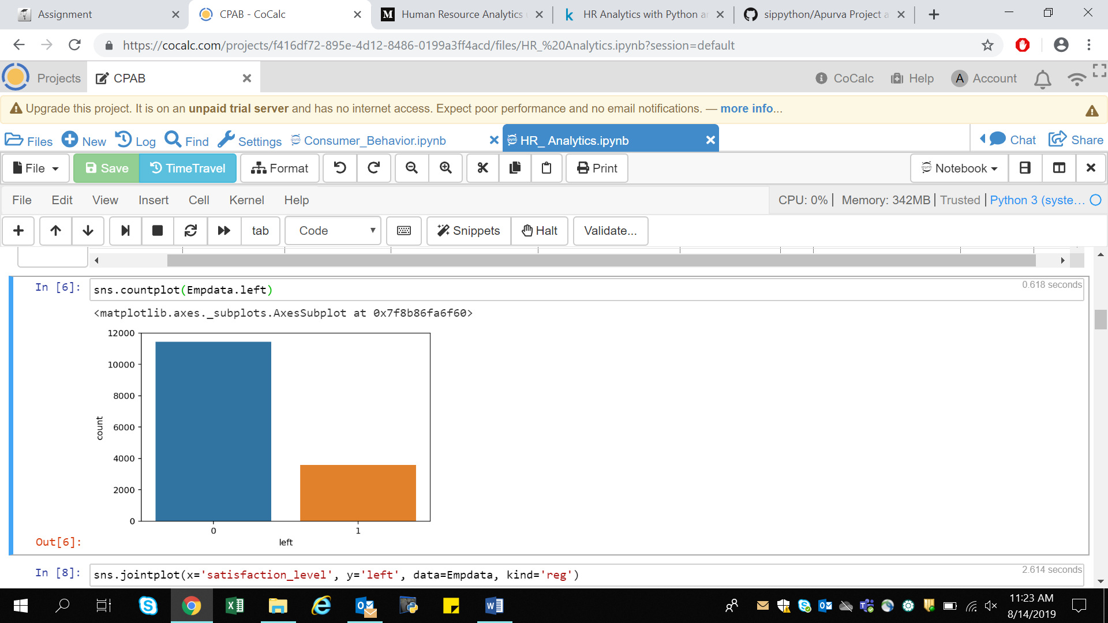

The above graph represent the employee ratio who have left the company and the one still present in the company. ‘1’ represent the number of employee who Left the company and ‘0’ for the Active employee.

1. Employee Satisfaction Level

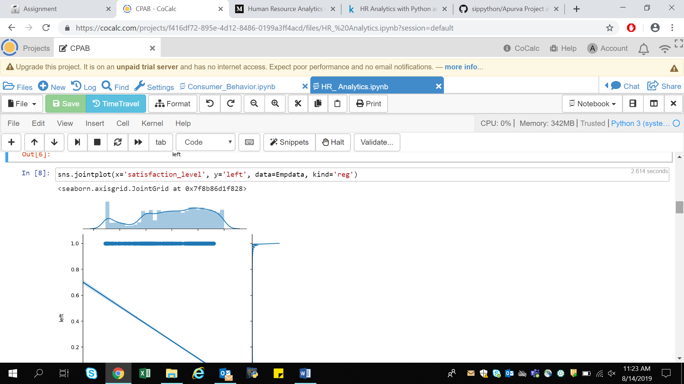

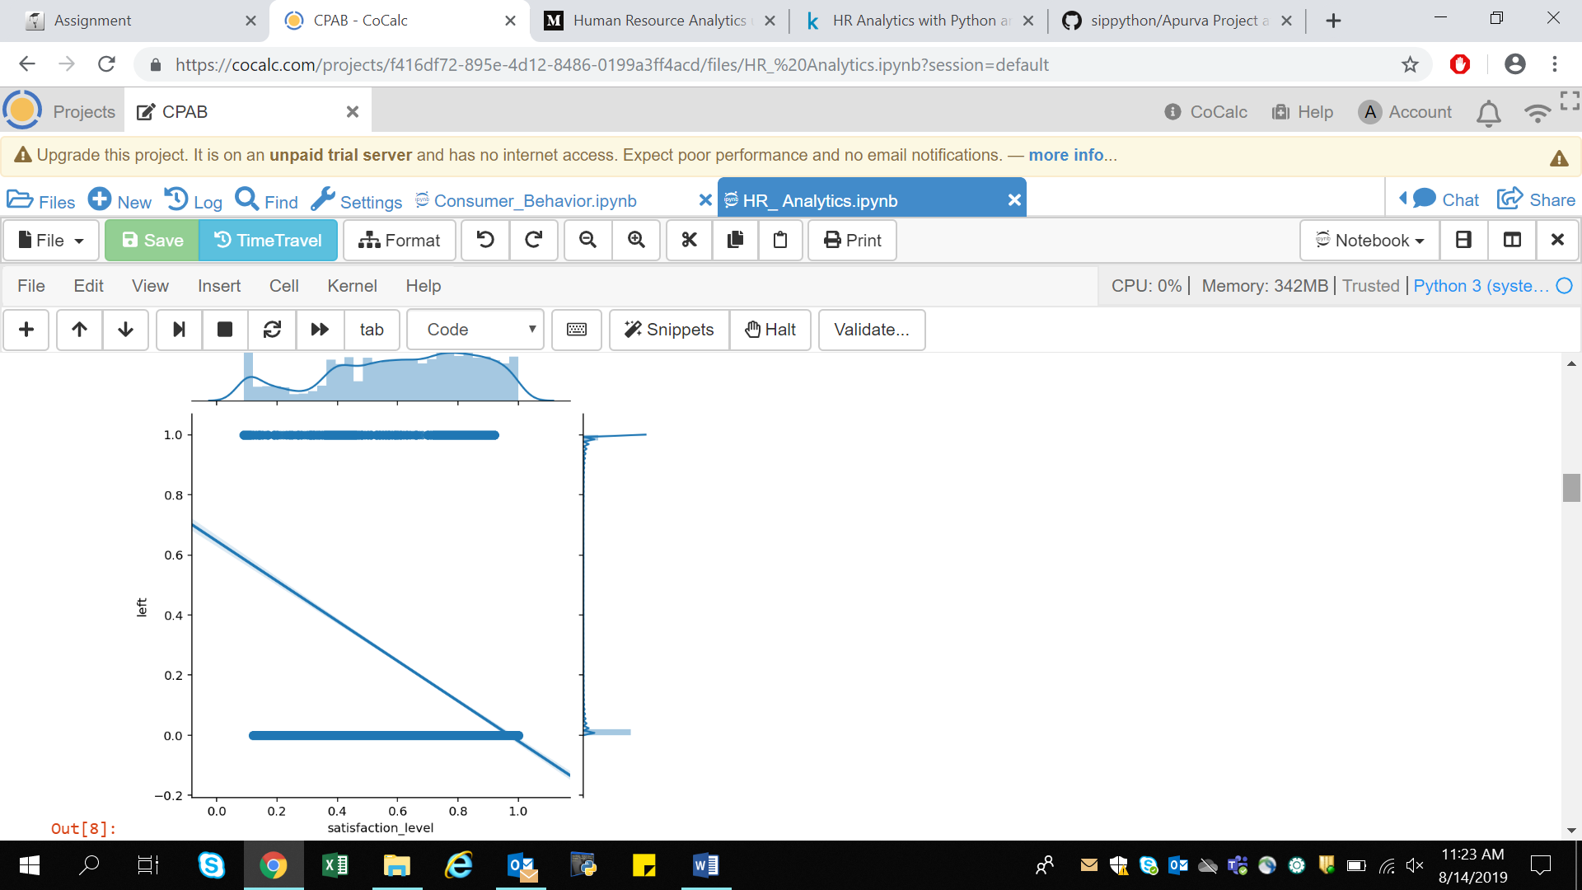

The above graph represent the satisfaction level of left employee in the company. Unsatisfaction of employees has an influence on their leaving. Here we have used line of regression for left employee data.

In the dataset sales represent different department of an organization.

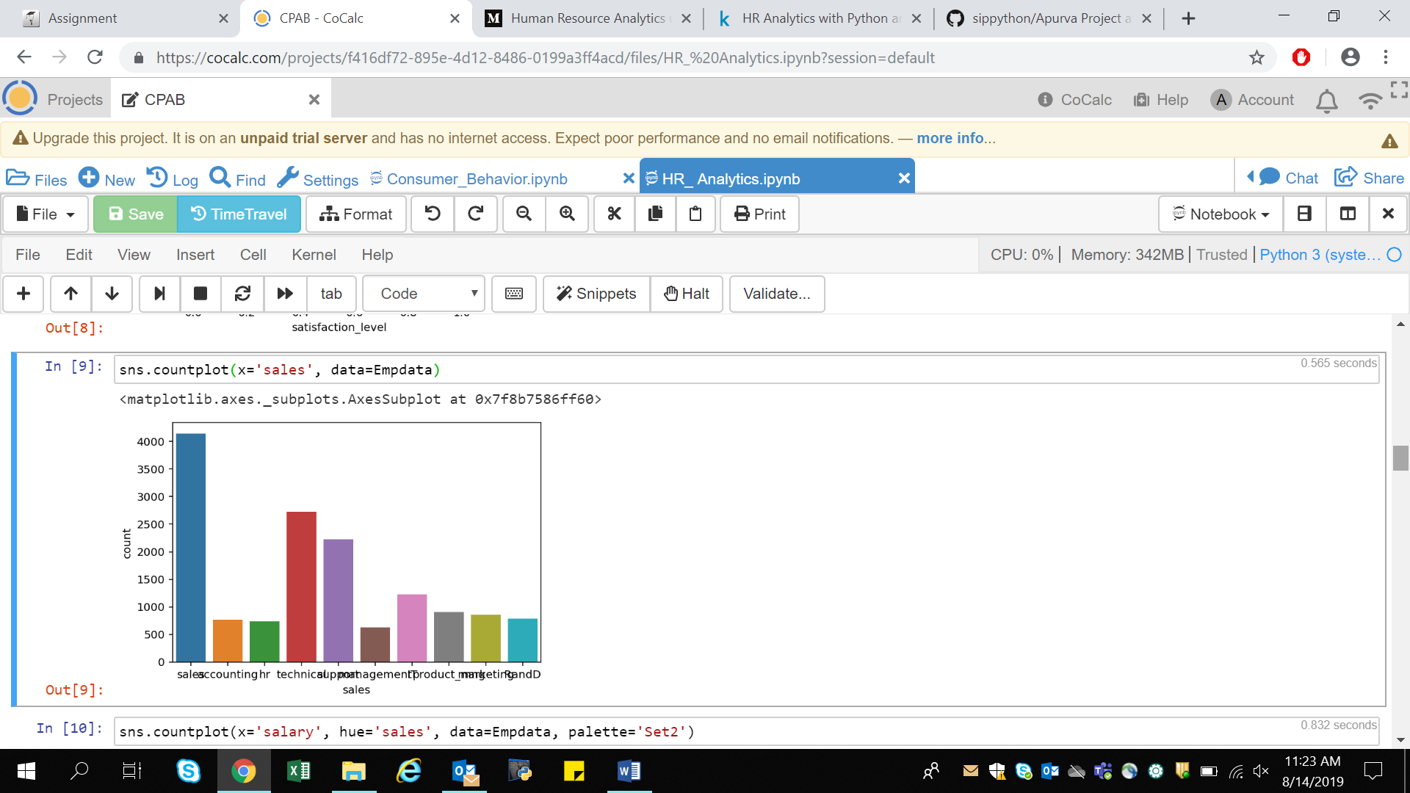

The above graph represent the number of employees working in different department of the company where sales have the highest number of employee followed by technical,support etc. with least number of employees in product_management.

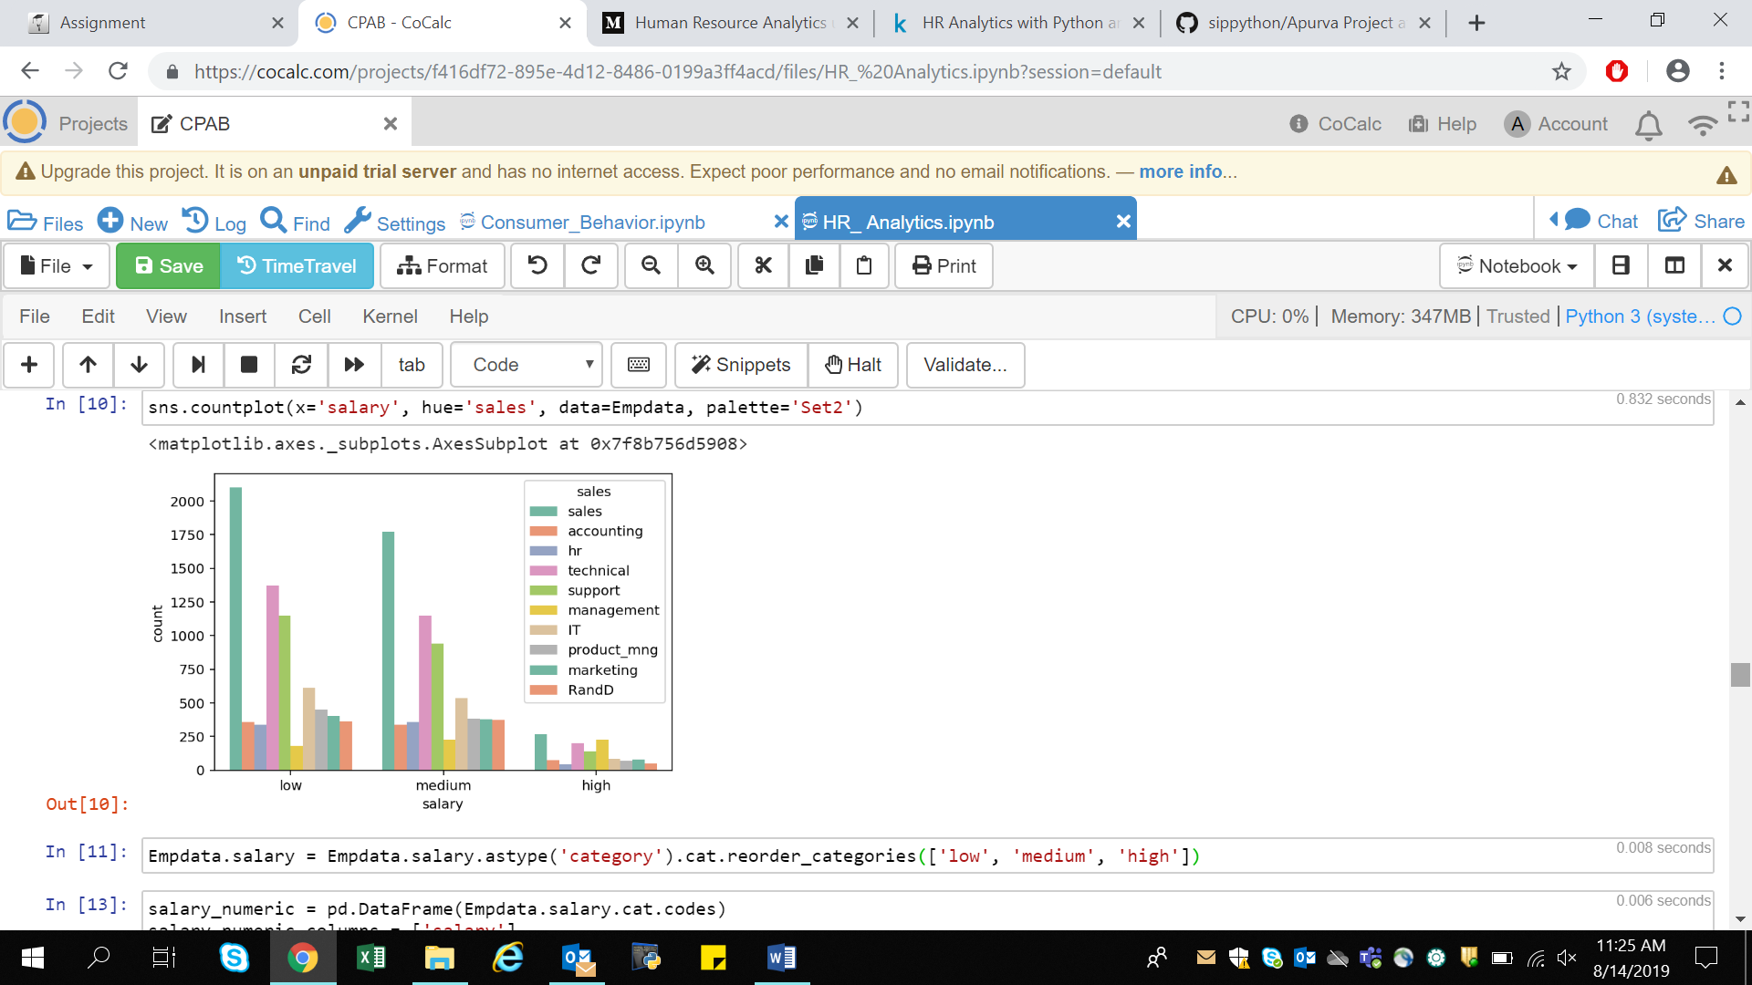

The above graph represent the salary based on the department of the company from low to medium to high where sales department leads from having the highest number of employee for having high salary to low salary followed by technical department.

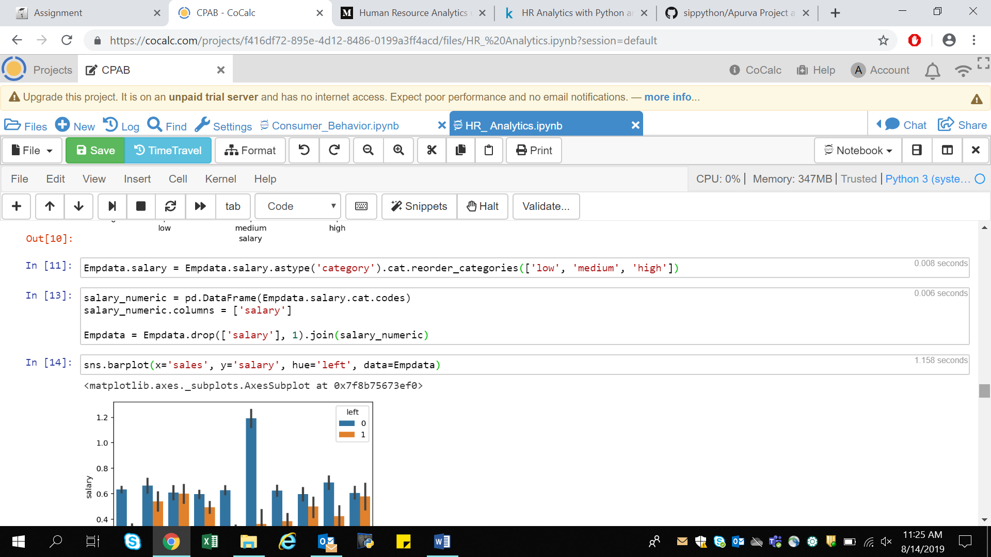

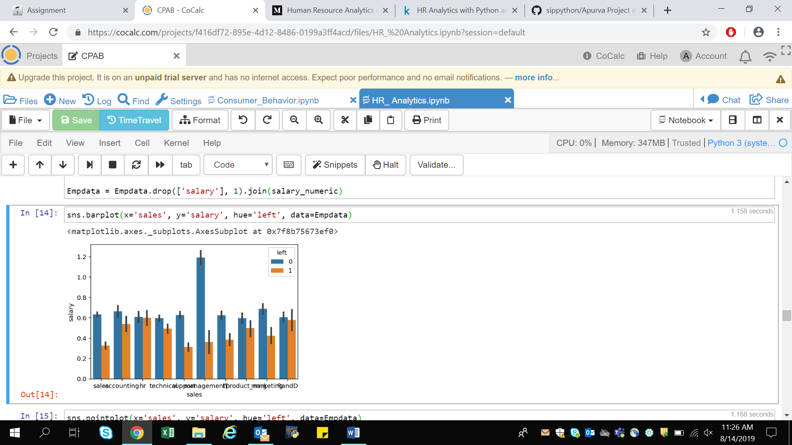

The above graph represent how many employees in a department left/stayed when comparing with their salaries. Depicting that whether the low salary was the reason for employees leaving.

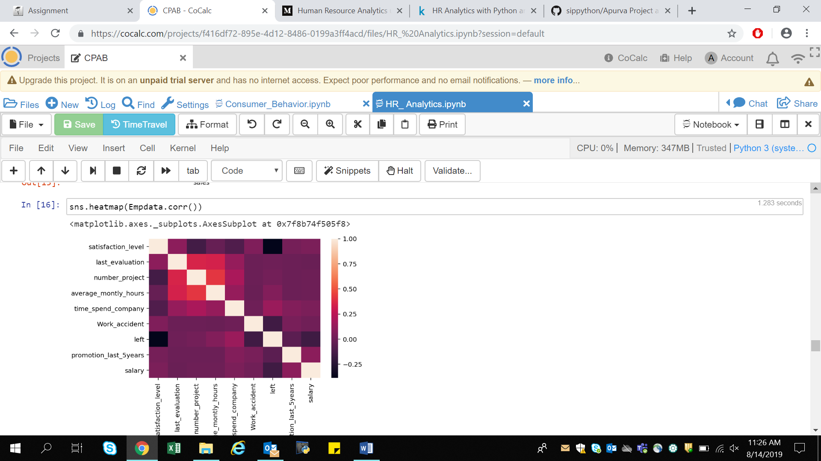

A heat map is a two-dimensional representation of data in which values are represented by colors. A simple heat map provides an immediate visual summary of information.

Here heat map is used to find the correlation between left and satisfaction level of an employee.

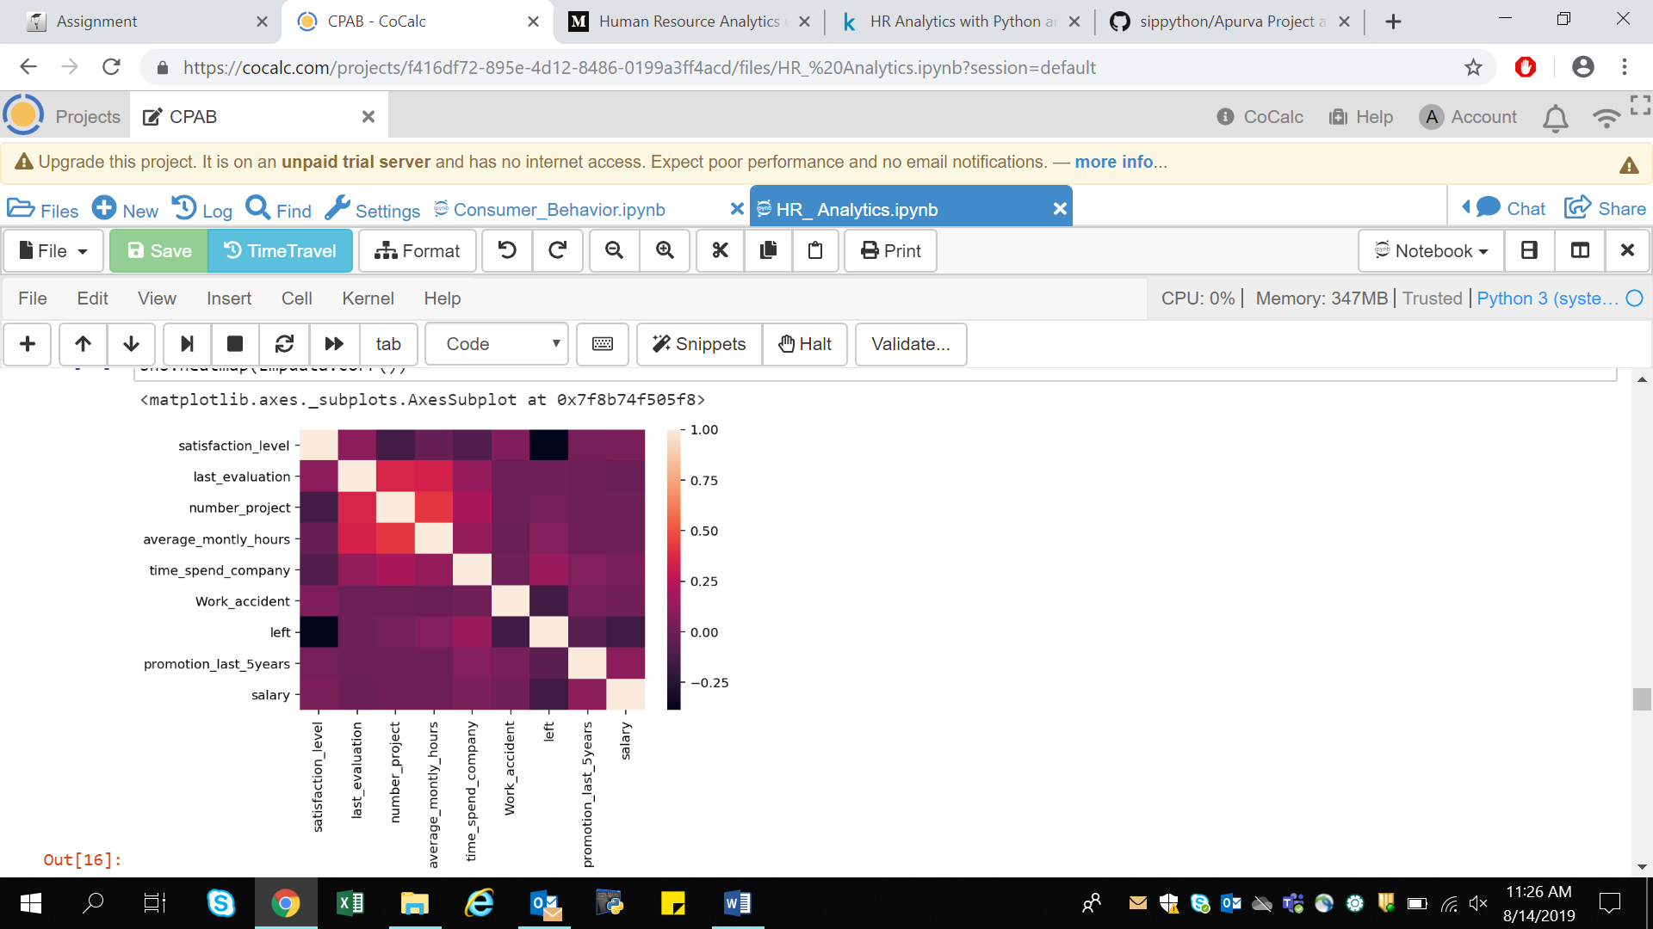

Correlation shows a linear relationship between left and satisfaction_level.

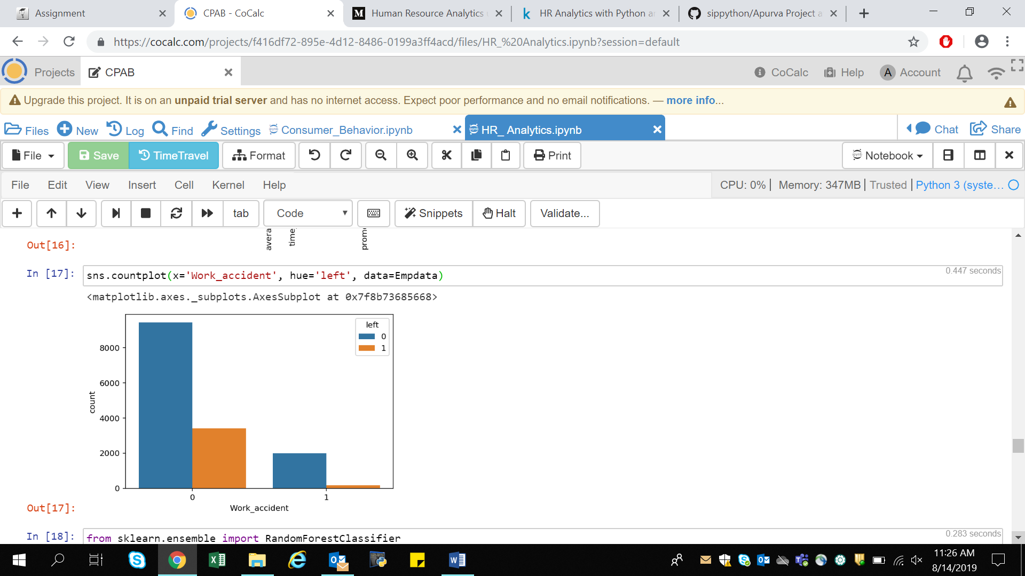

For Building the Predictive Model I will be using

1. Random Forest Classifier
2. Decision Tree Classifier

1. Random Forest Classifier –

The Random Forest is chosen over other algorithms because it uses the entire dataset optimally which reduces bias error. The algorithm is also famous for providing maximum reduction in variance as it gives the average output from an ensemble of several decision trees; hence the name ‘Random Forest’.



We then train the **Random Forest Classifier** model. For checking the accuracy of the model here will be using objectname.score() function.

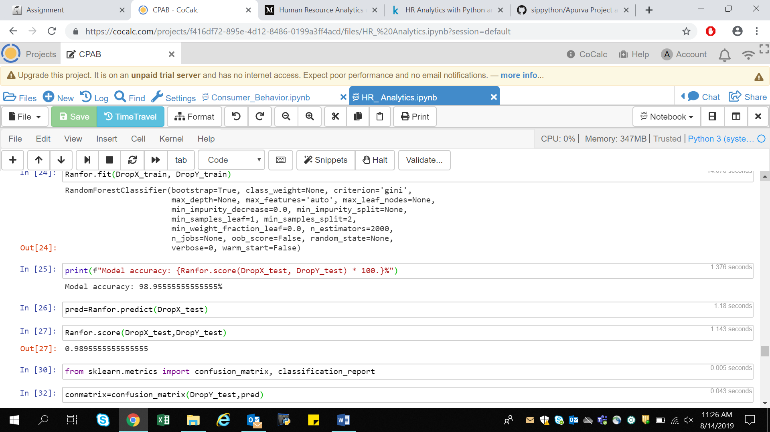

Model Accuracy comes out to be 98.9%

Which implies there are very few misclassifications and the precision rates for all the values are very high and therefore implies that our model is highly accurate.



Confusion matrix-

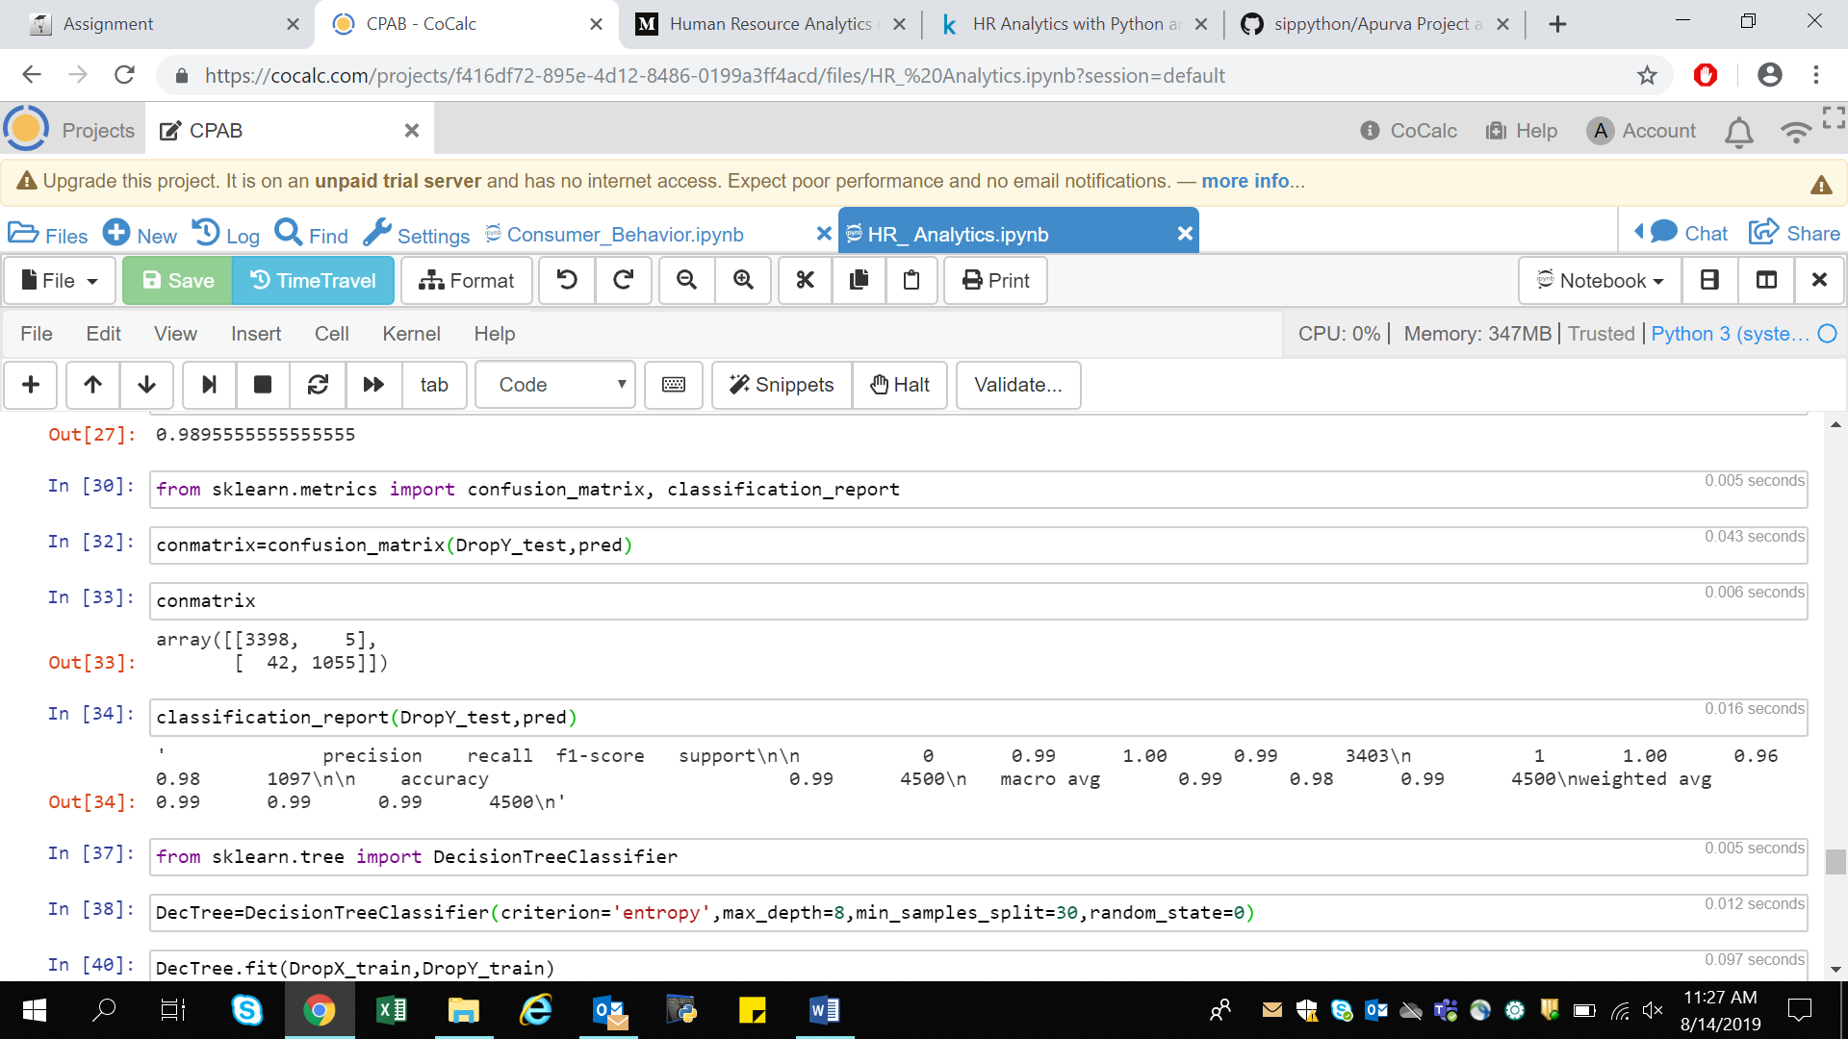

2. Decision Tree Classifier -

Importing the classifier, fitting the train and the test set into it and then making predictions with the test set.



Cross-Validating to check the number of misclassifications

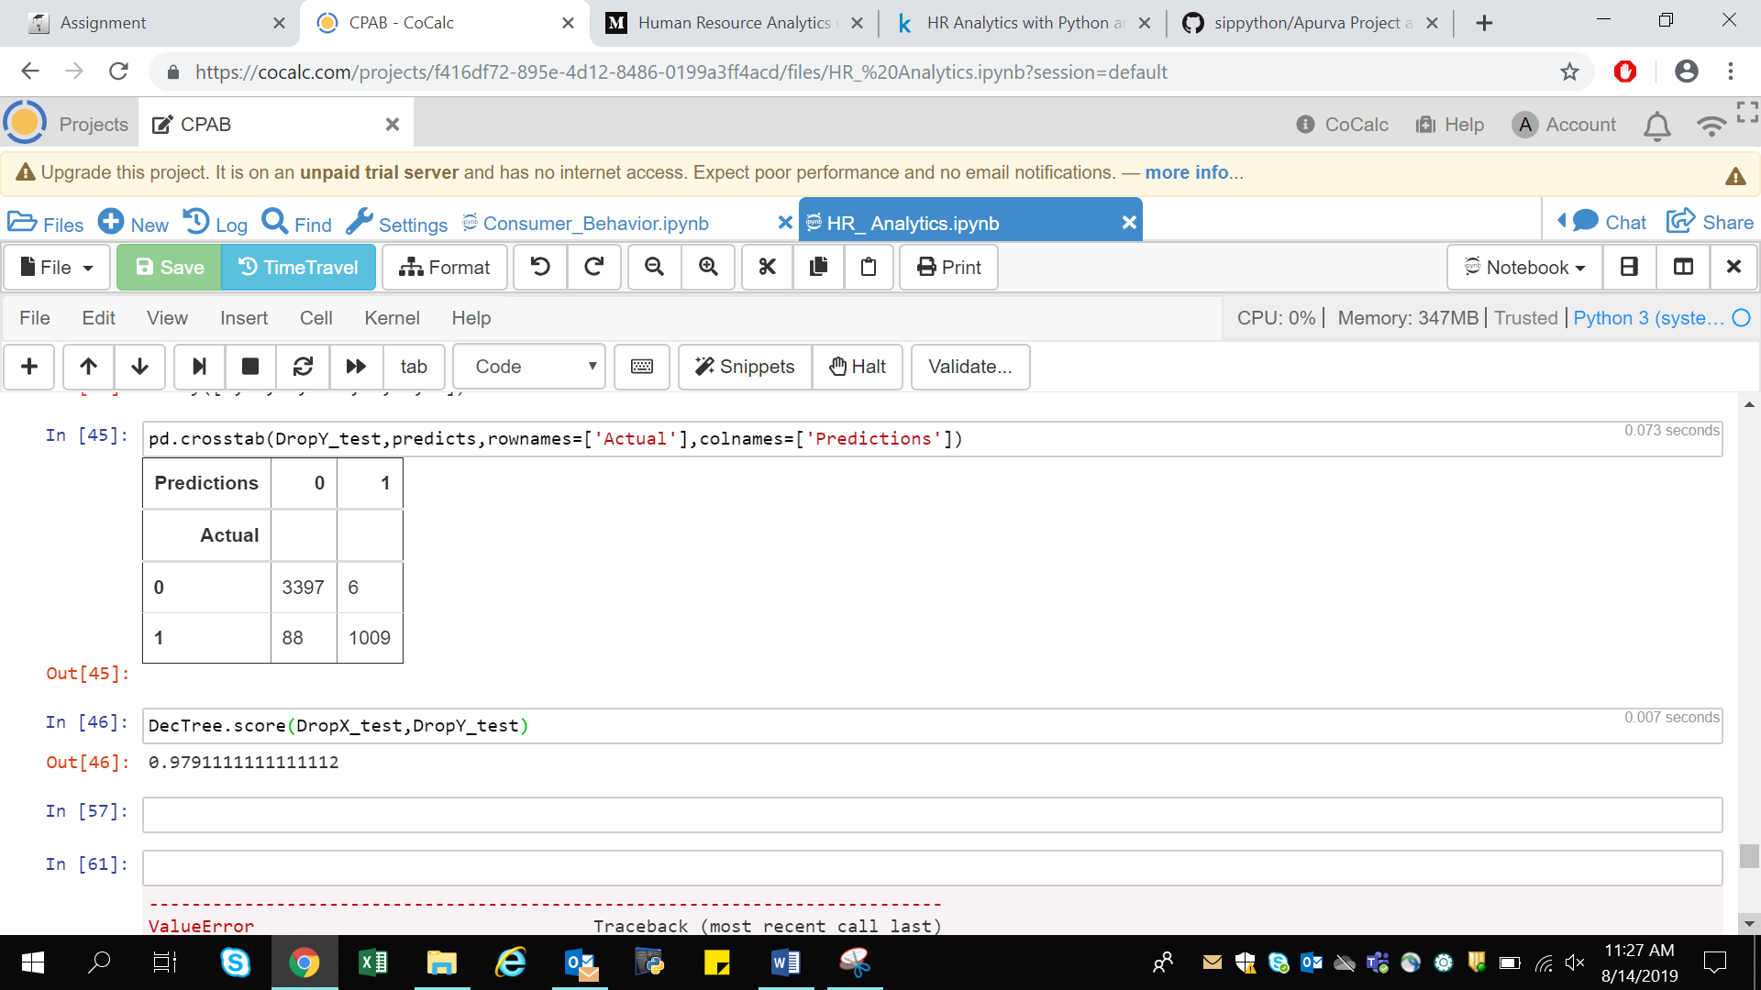

The accuracy of the model comes to be 97.9% . As the model score is also high so therefore there are very few misclassifications and the precision rates for all the values are very high and it implies that our model is highly accurate.